ENVIRONMENT CREATION

Step: 1 Creating Iris_ proj with python version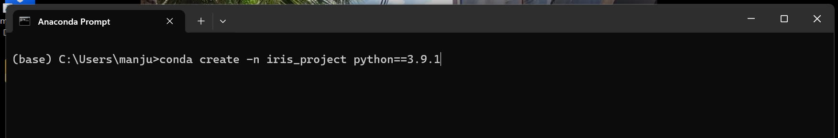

Code: conda create –n iris_project python==3.9.1

Step: 2 Proceed with y



Step: 3 Result

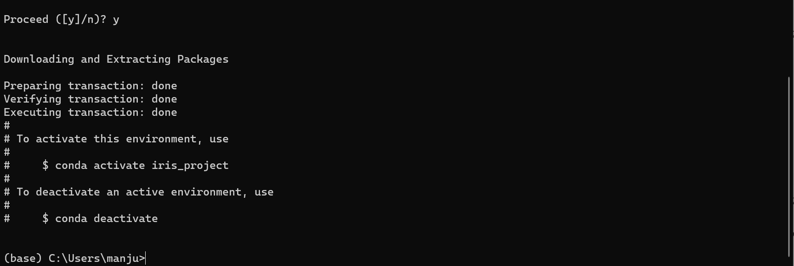

Step: 4 Activate Iris_Proj



Step: 5 Installing Jupyter Notebook

Screenshot 2023-11-17 144349.png

Step: 6



Step: 7 Installing Libraries

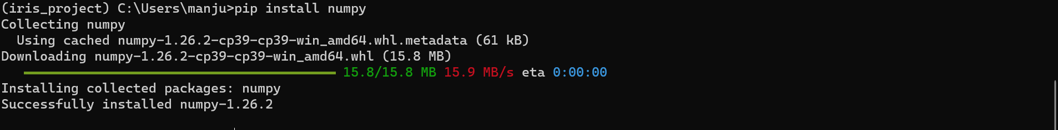

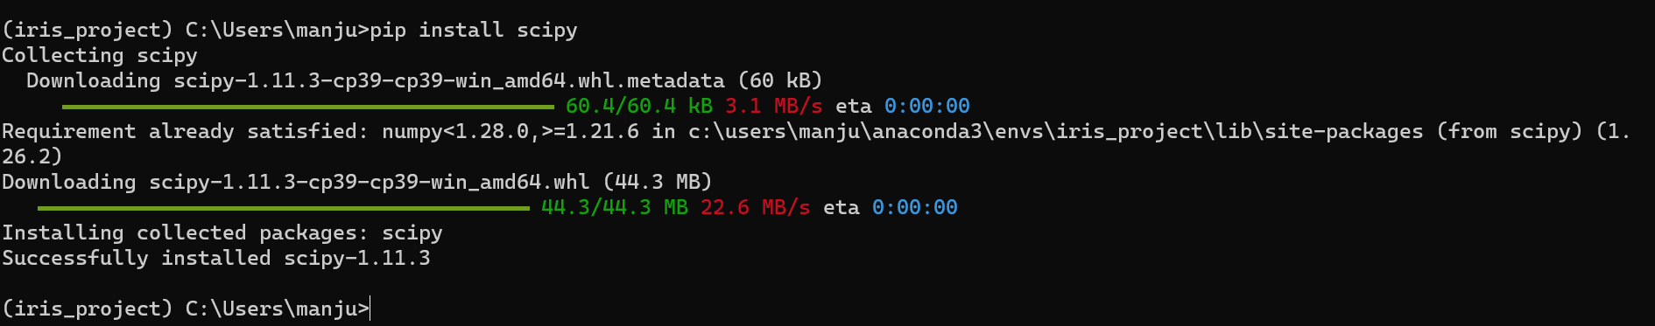

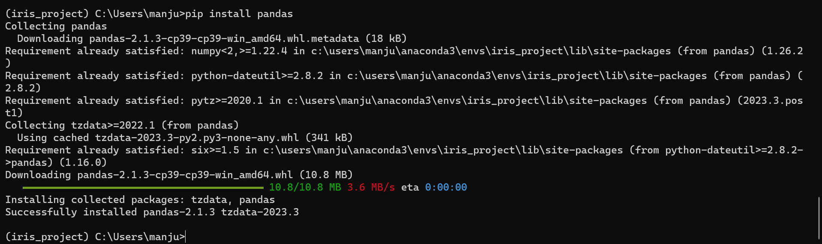

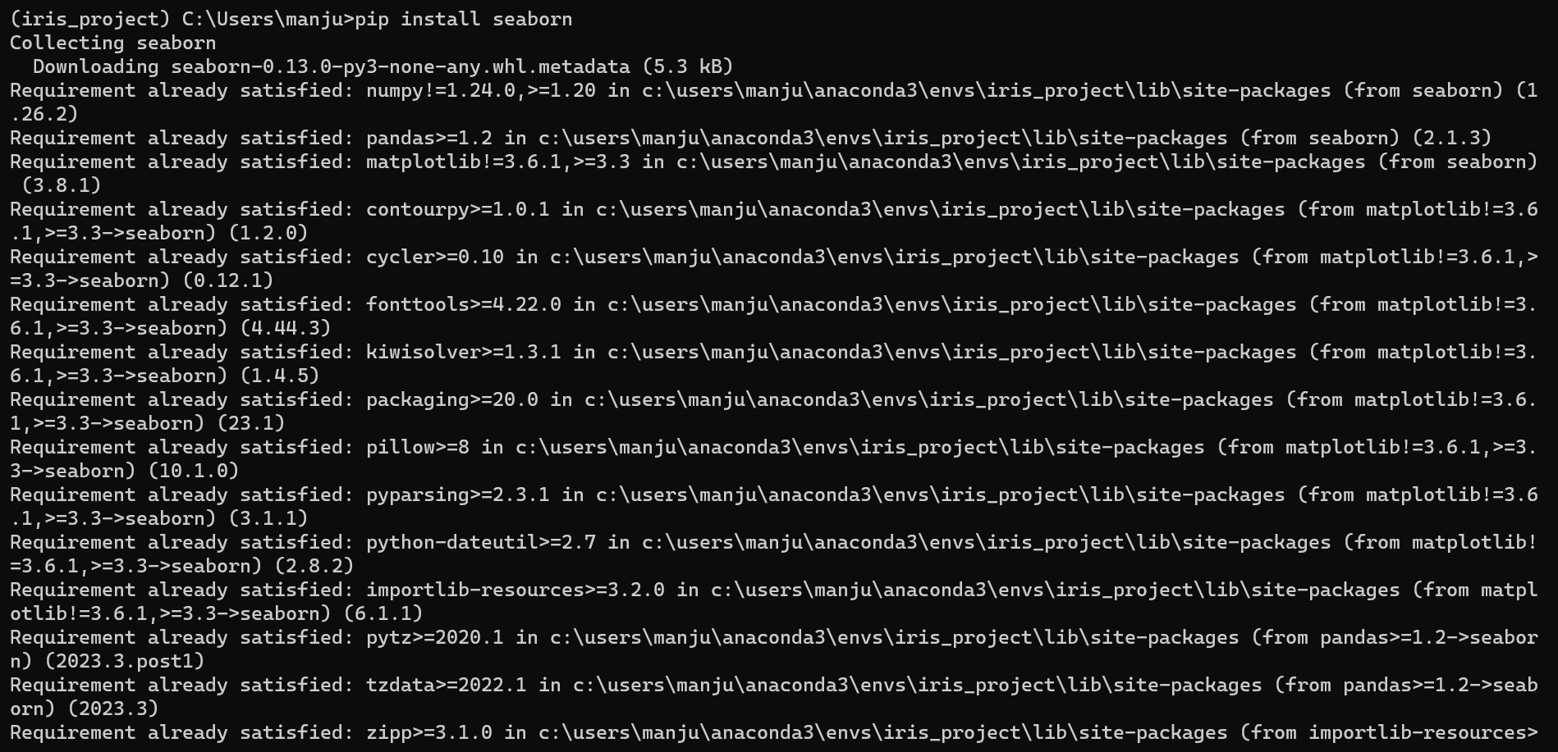

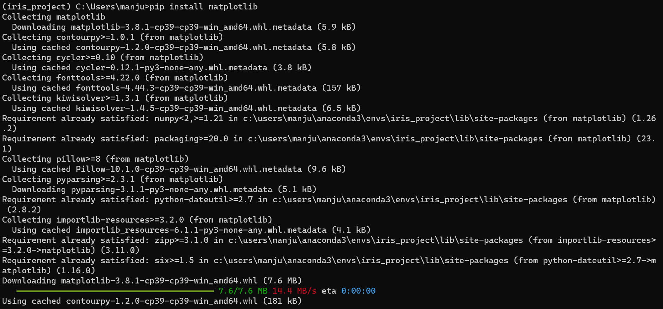

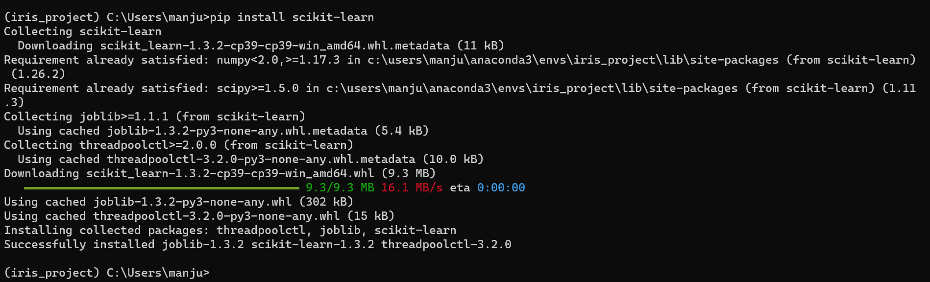

Step : 8 Open Jupyternotebook

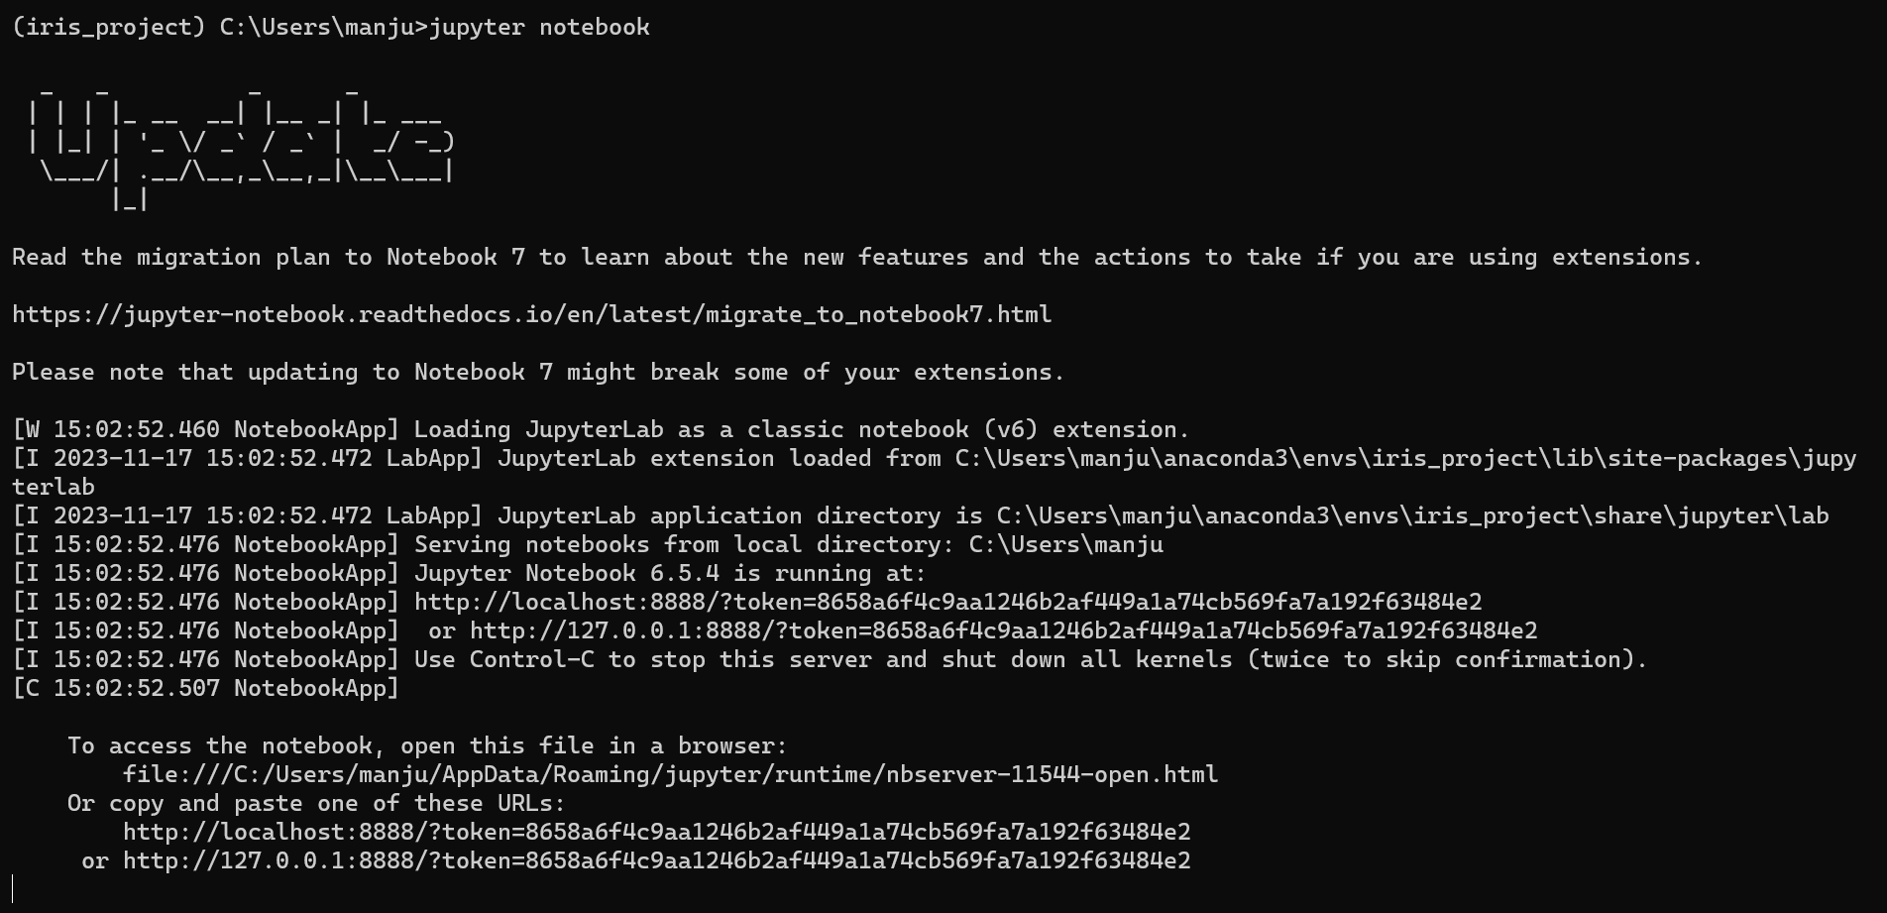

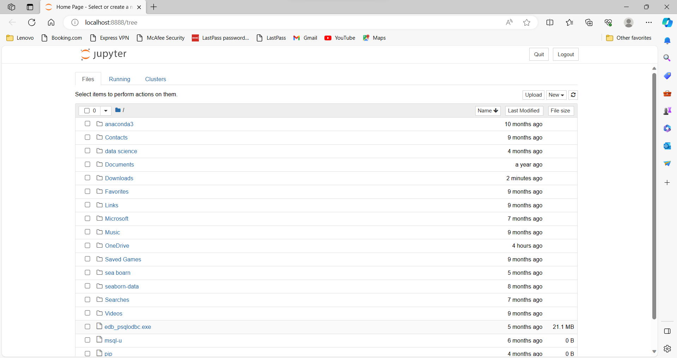

Project begin from here:

Folder N ame: Database _creation 1

Step: 1

Importing Libraries

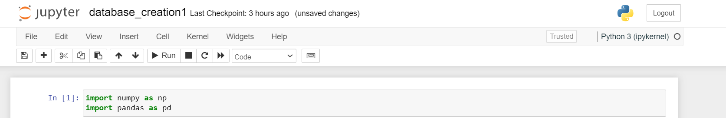

Step: 2 Loading CSV files

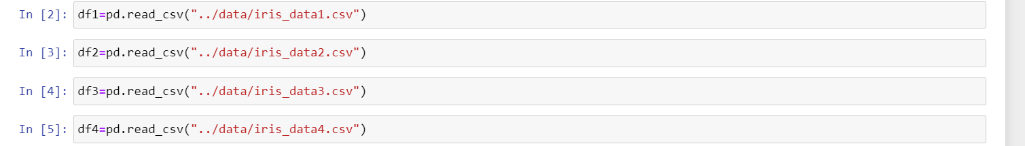

Step: 3 Head

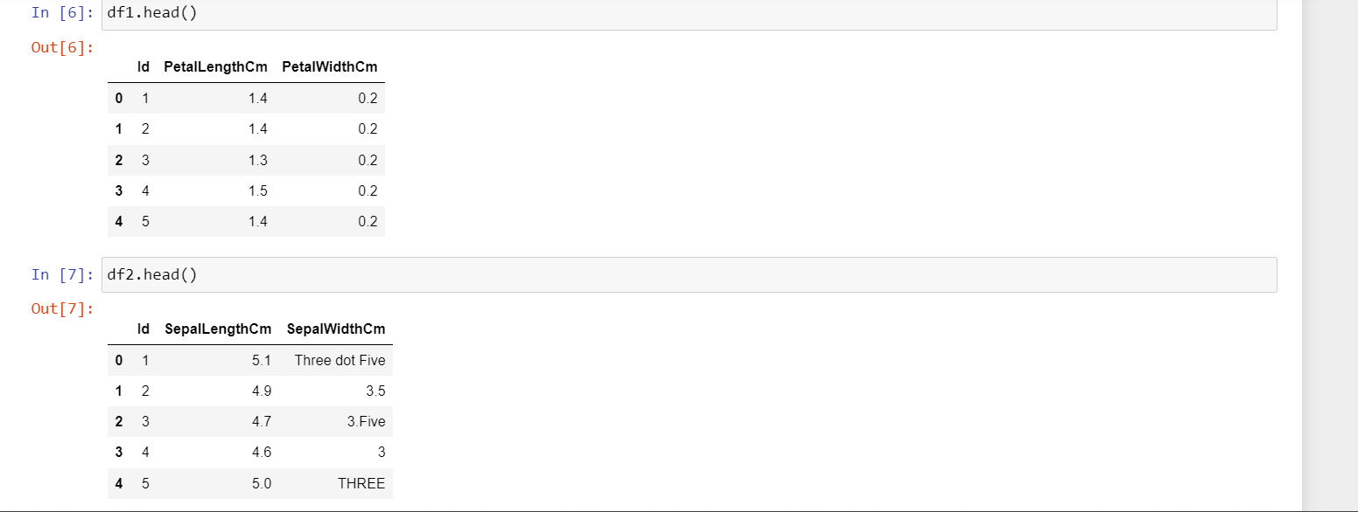

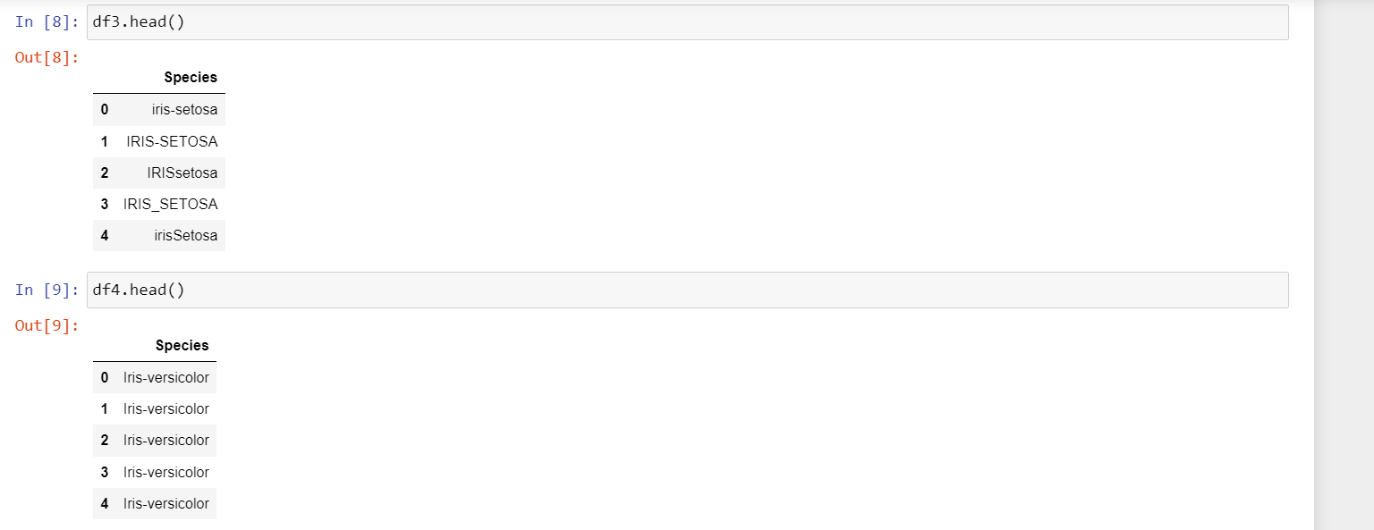

Step: 4 Connecting to My SQL

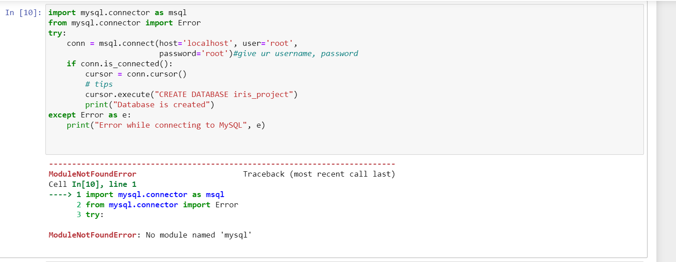

Step: 5

Here we did not install my SQL library so we got a error to retify the error we have to open again anaconda prompt and install the library

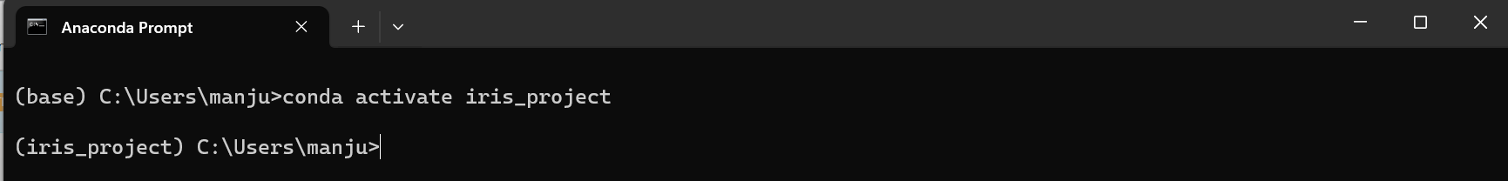

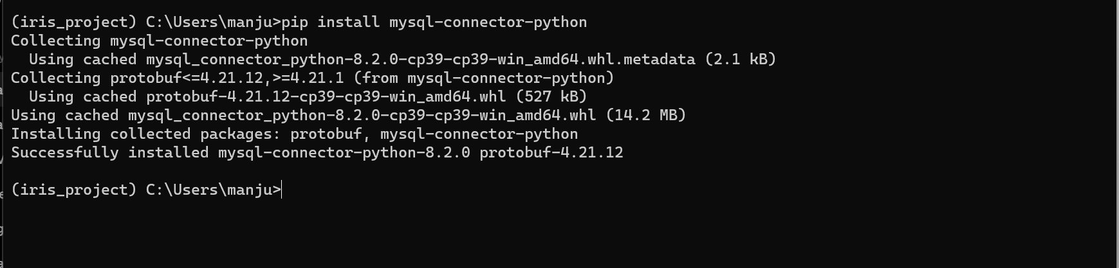

Step: 6

Again clear the output and restart the kernel here we sort the error

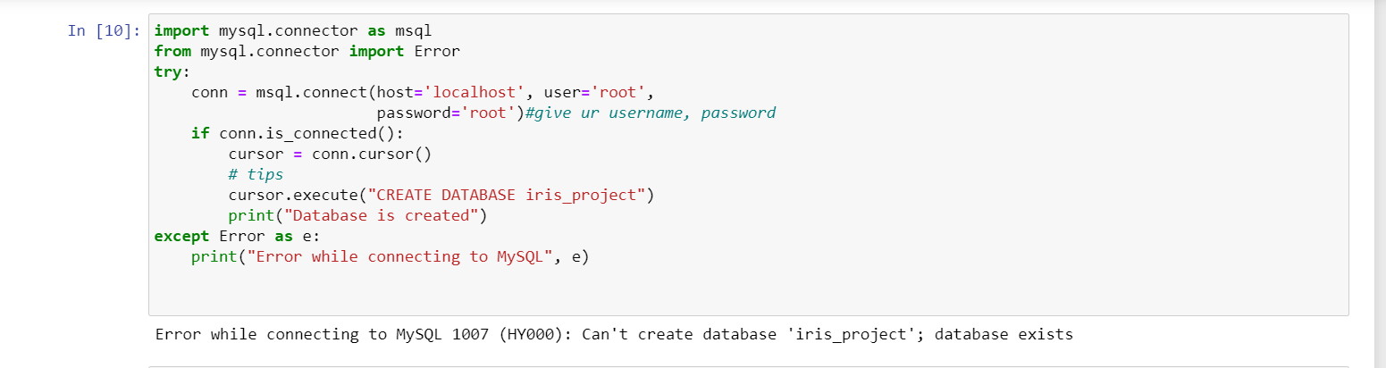

Step: 7

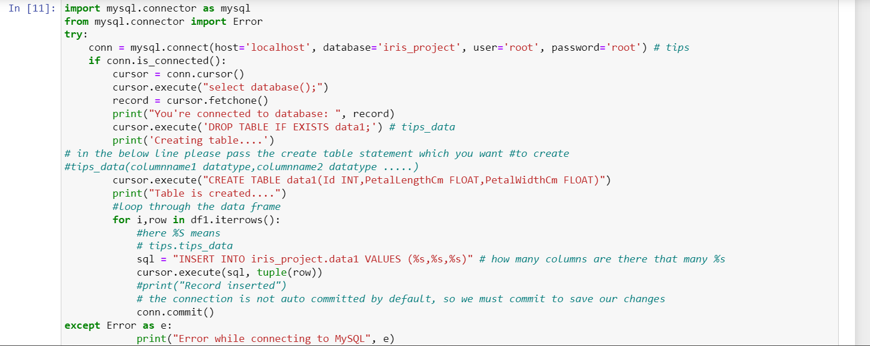



Step: 8

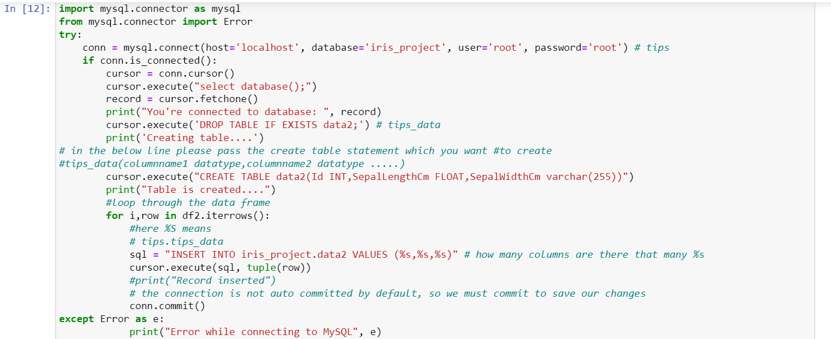



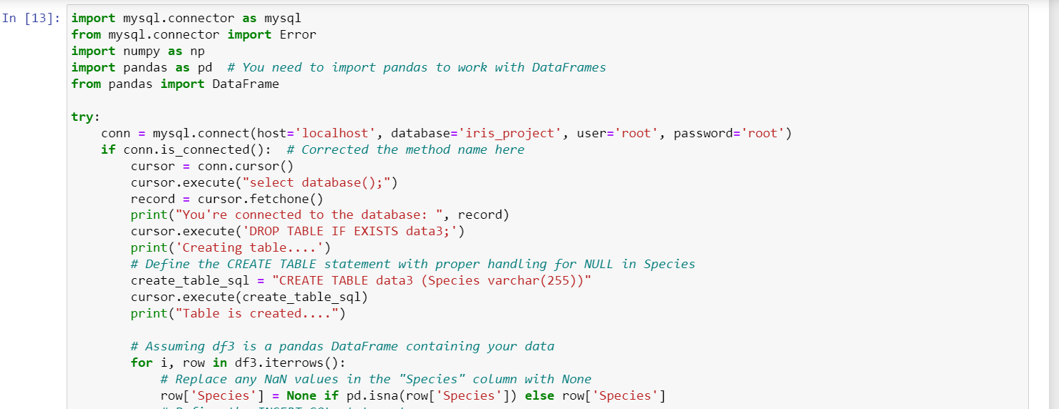

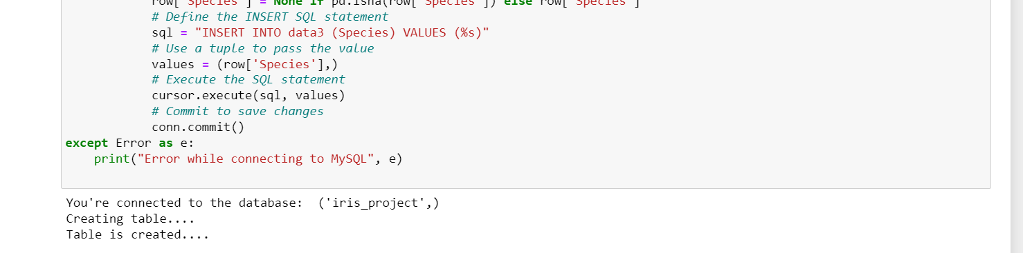

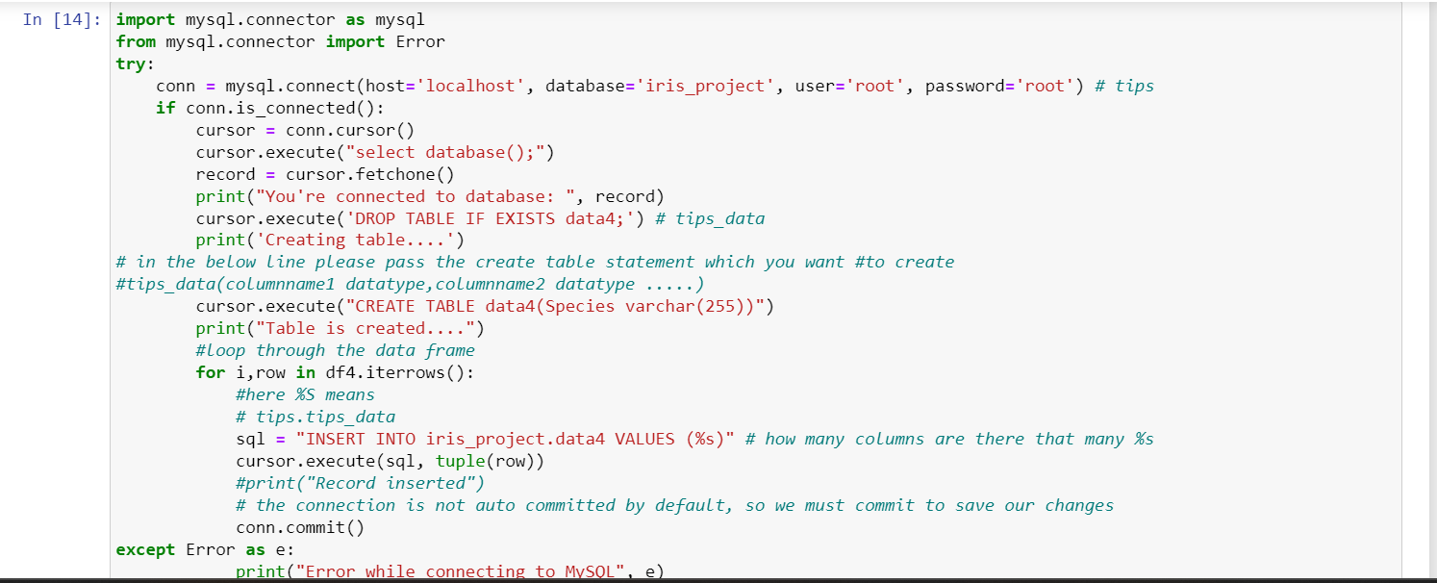

Next Folder Name: Pre processing _before_ cleaning 2

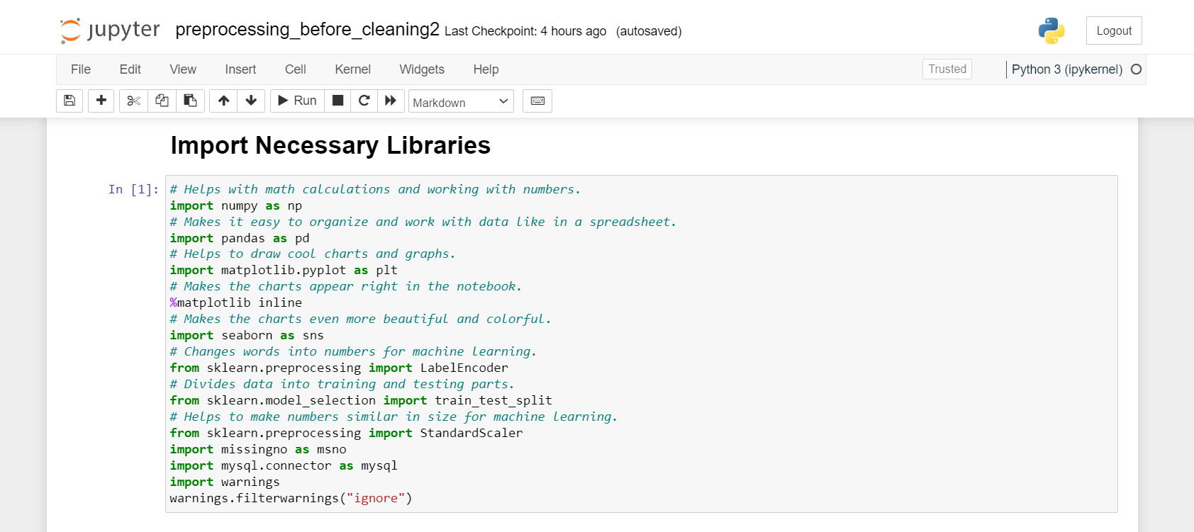

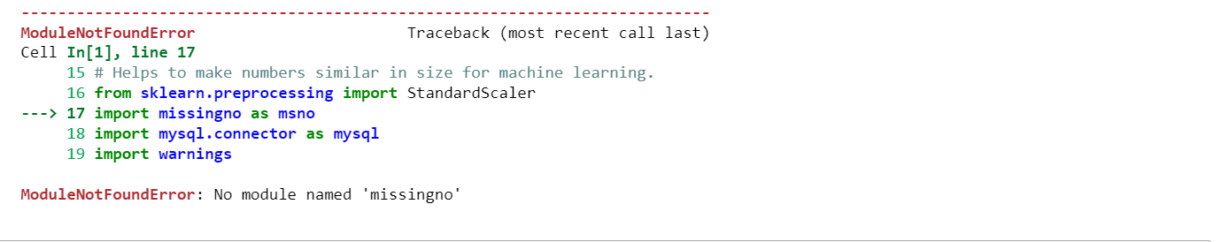

Again same process

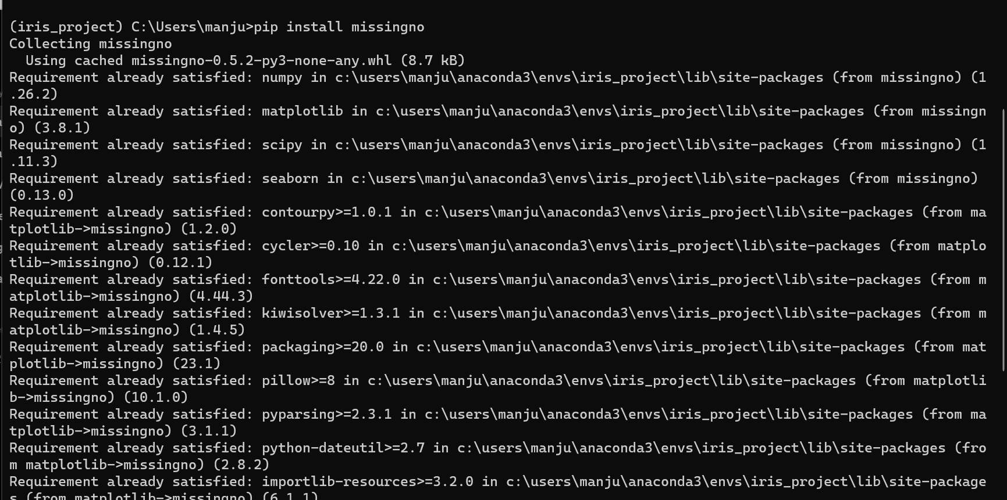

Step: R1 Importing libraries

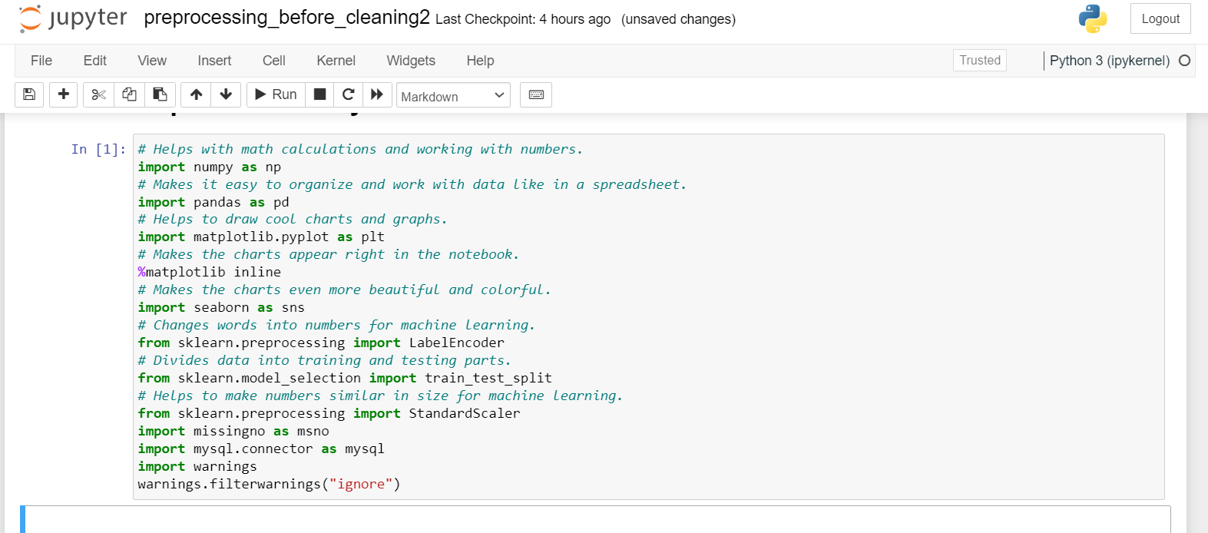

Step: 2 Loading CSV file

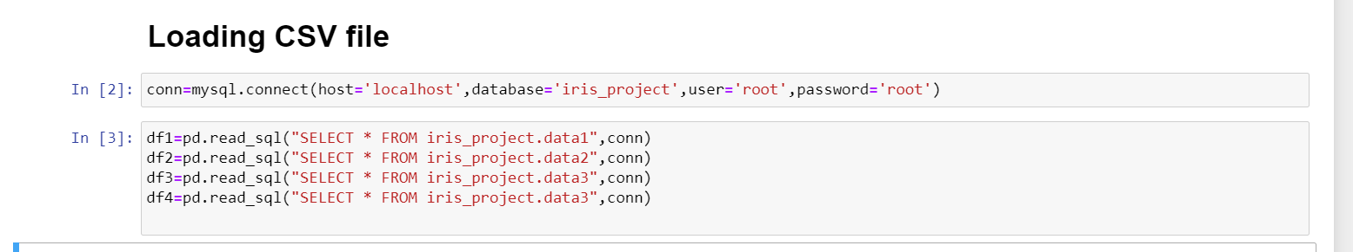

Step: 3 Head

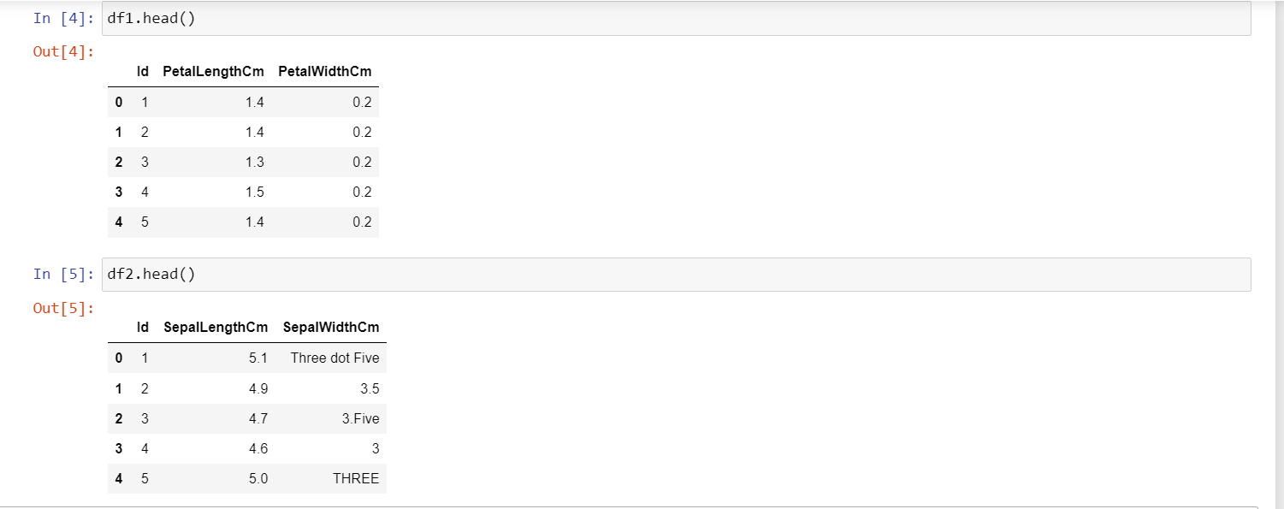

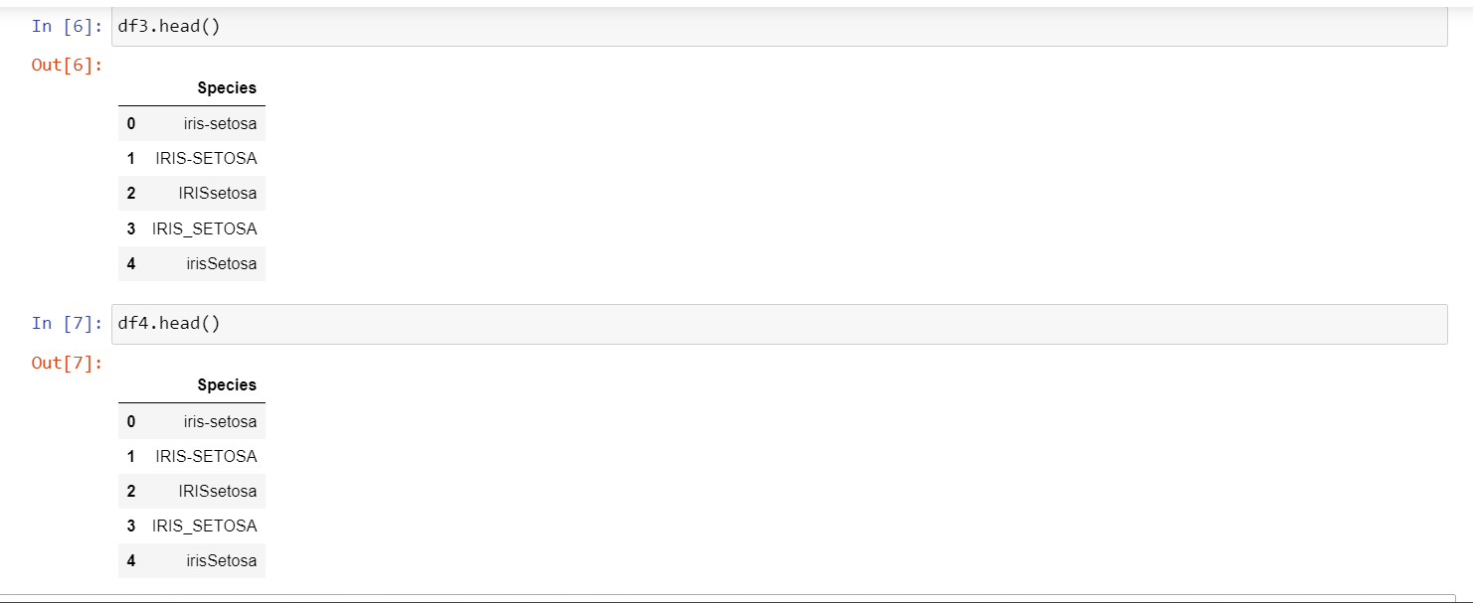

Step: 4 Tail

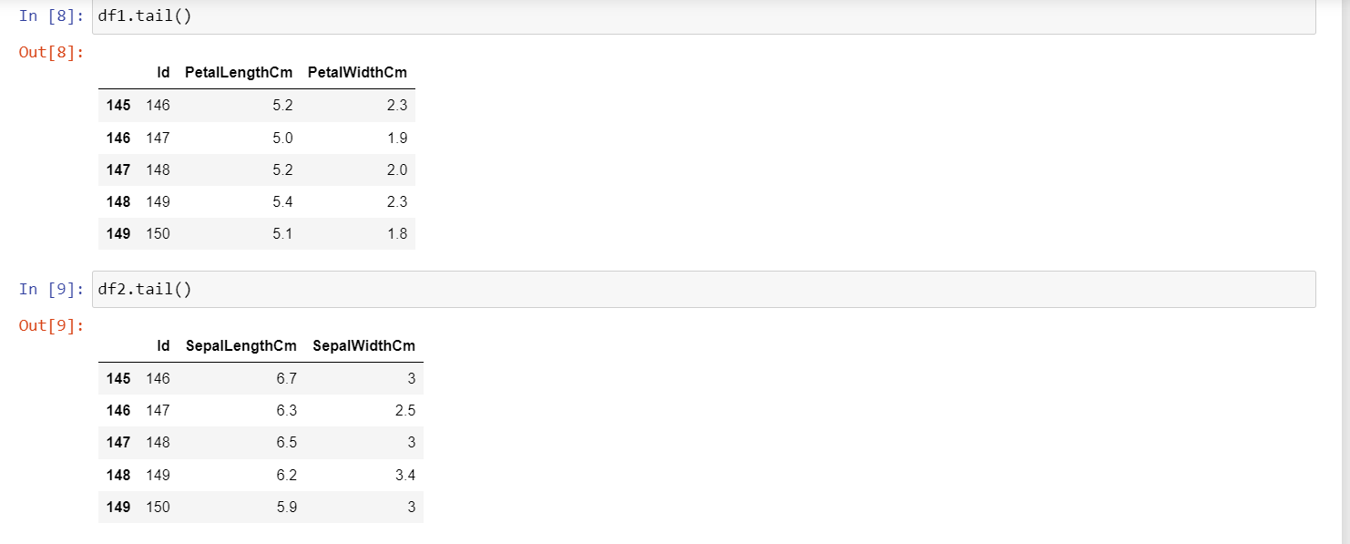

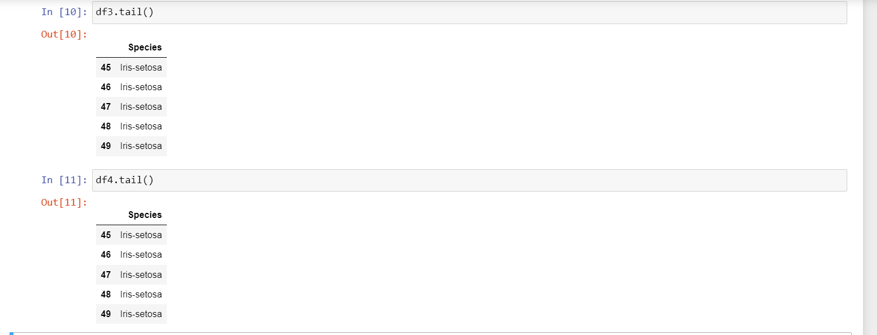

Step: 5 Shape of both Columns & Rows

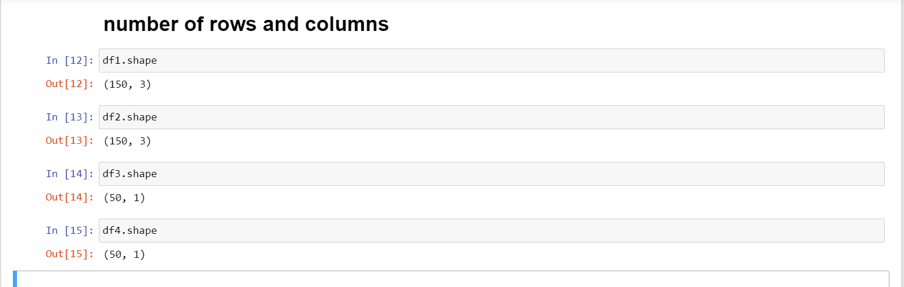

Step: 6 Describing Statistical Analysis of Data

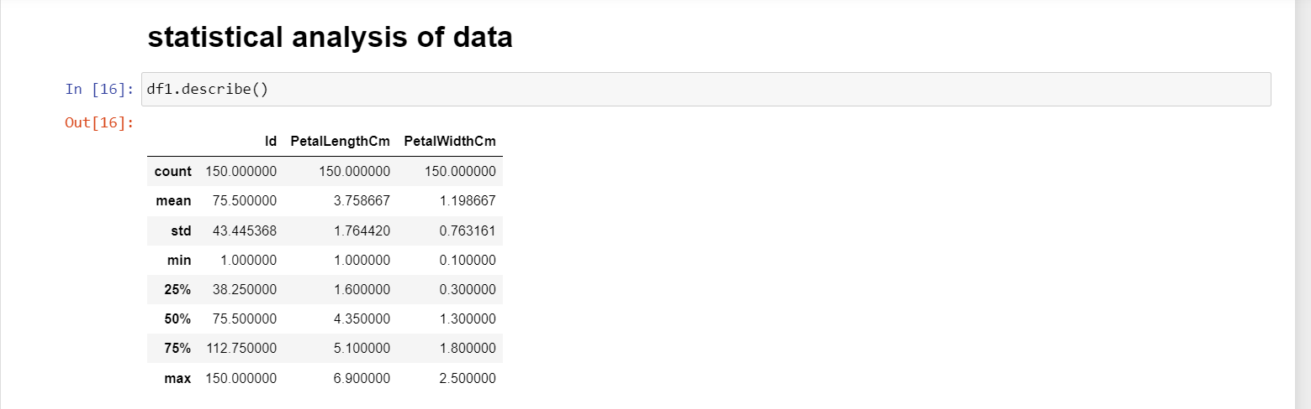

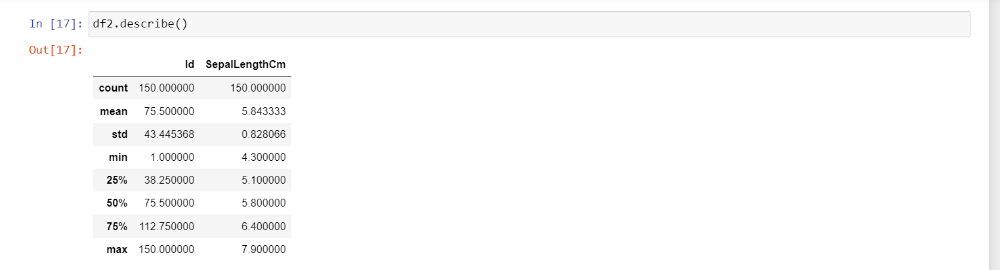

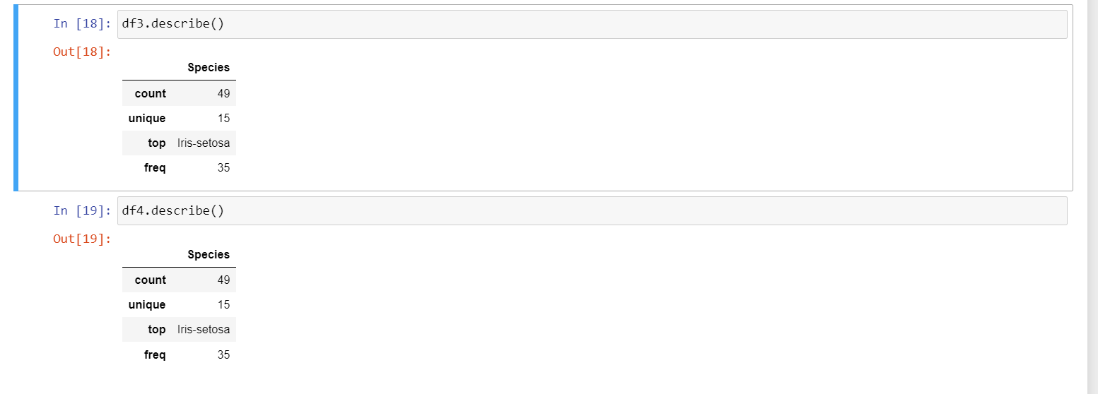

Step: 7 Finding Data type of Dataset

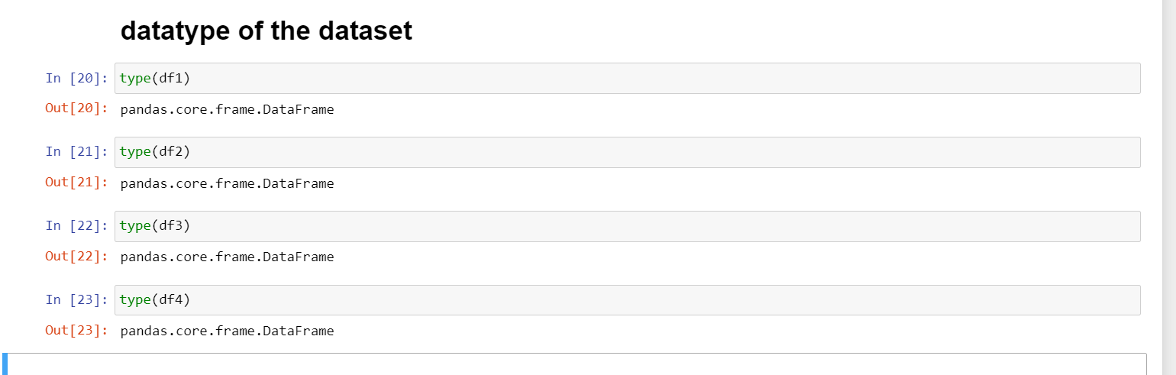

Step: 8 Information about Dataset

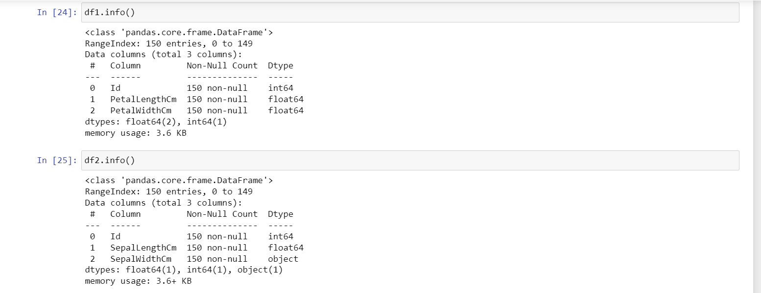

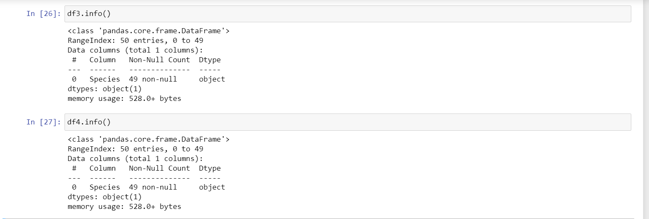

Step: 9 Displaying Columns of dataset

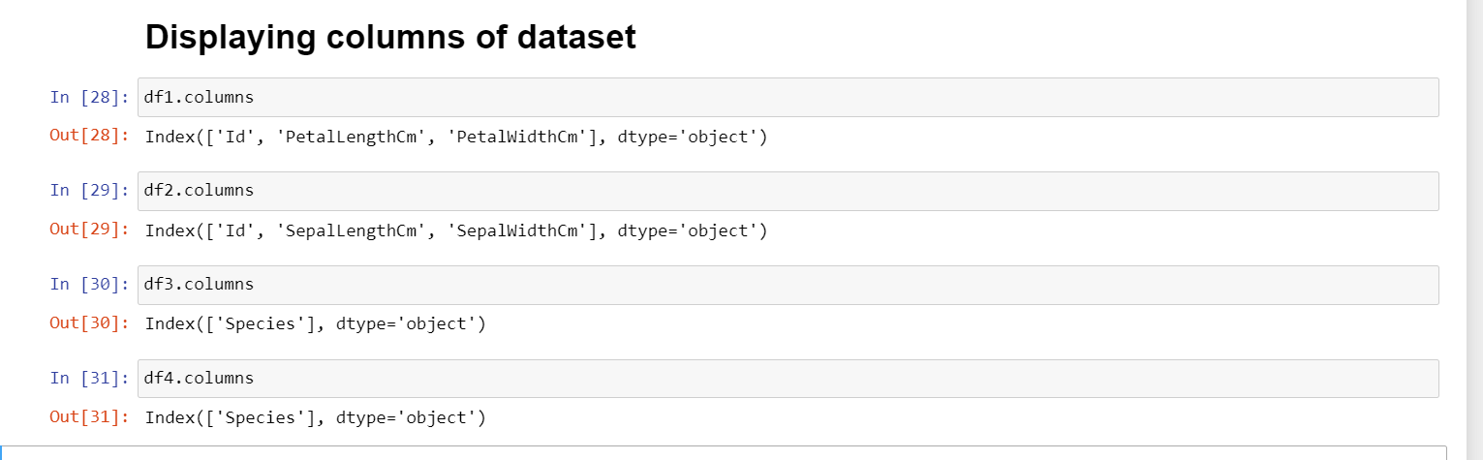

Step: 10 Count of the data

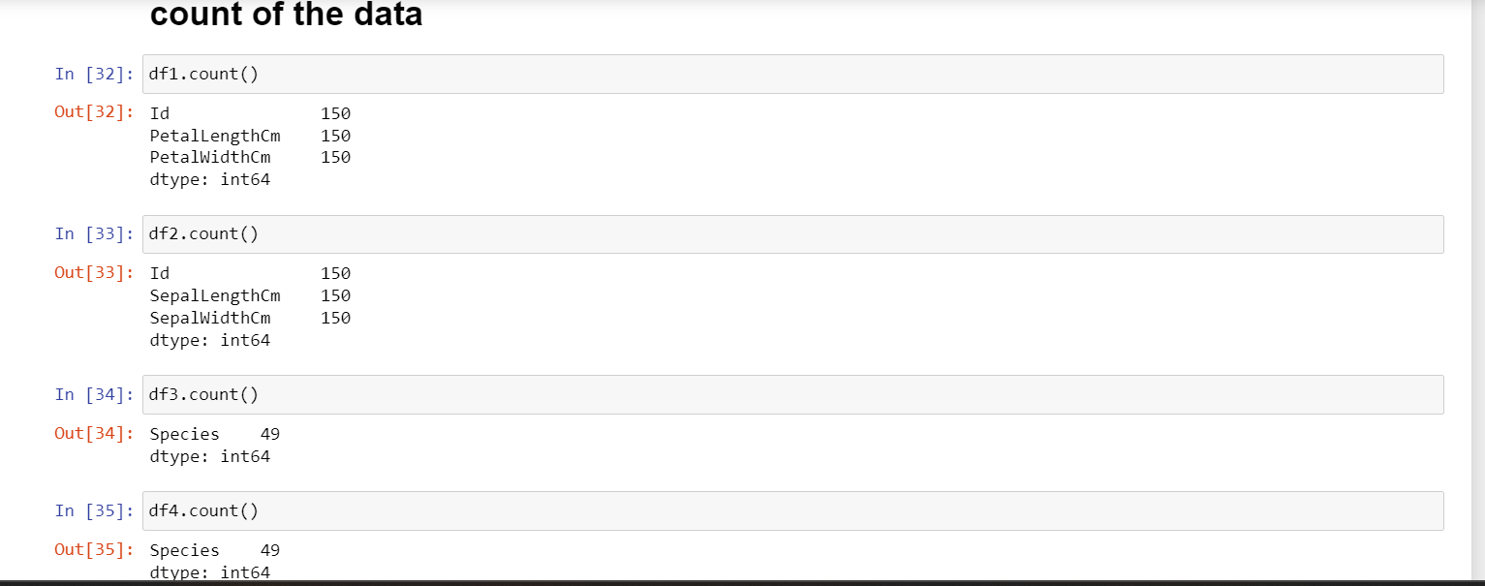

Step: 11 Finding Null Values

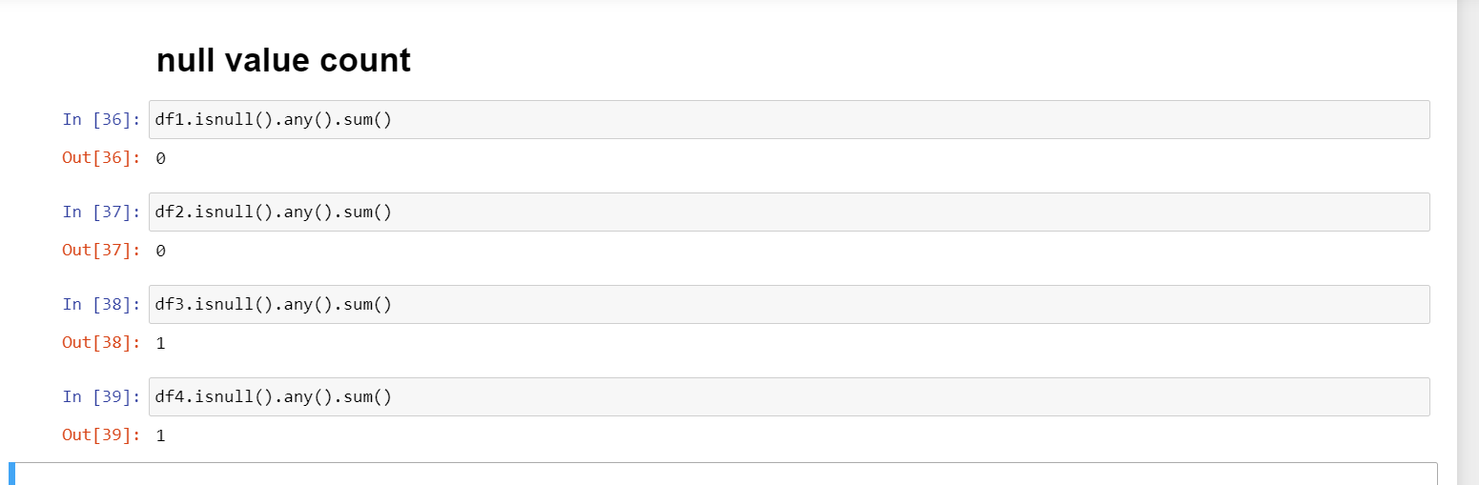

Step: 12 Finding d types

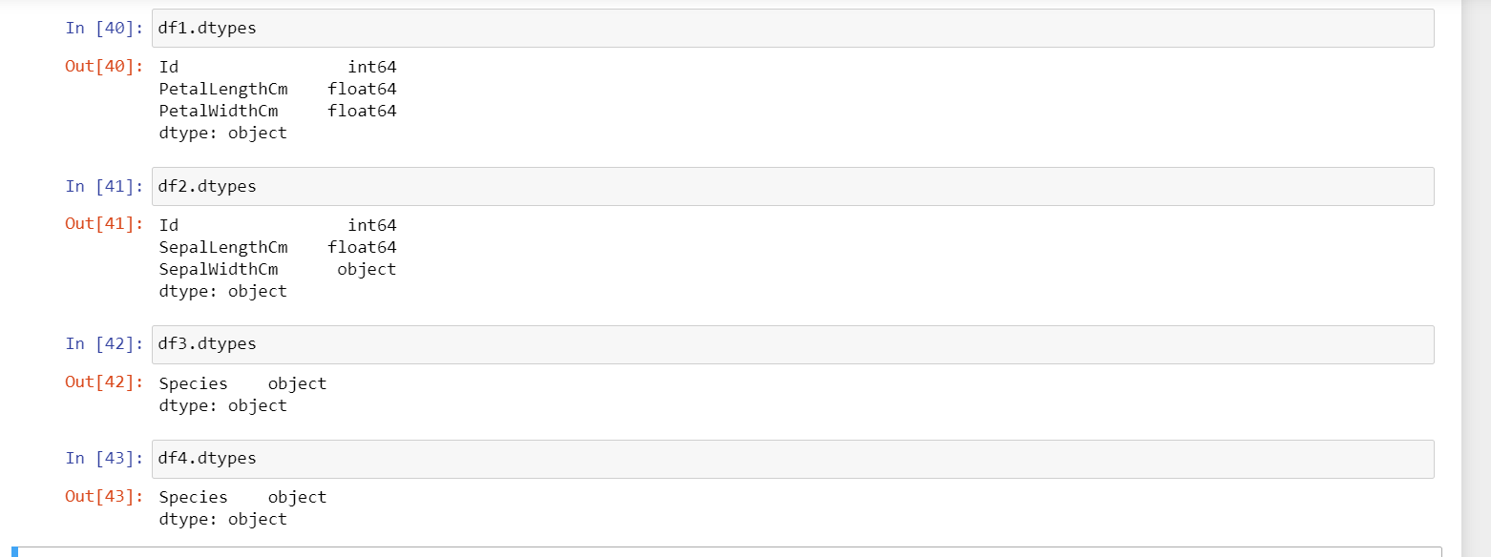

Step: 13 Finding no. of Dimensions

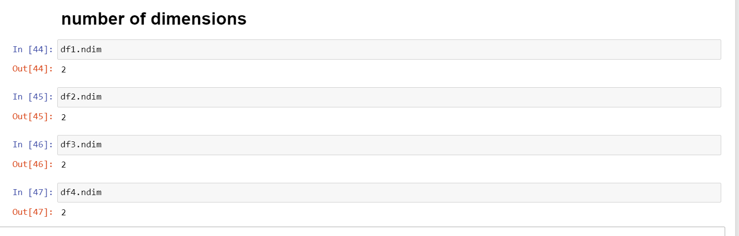

Step: 14 Finding Duplicates

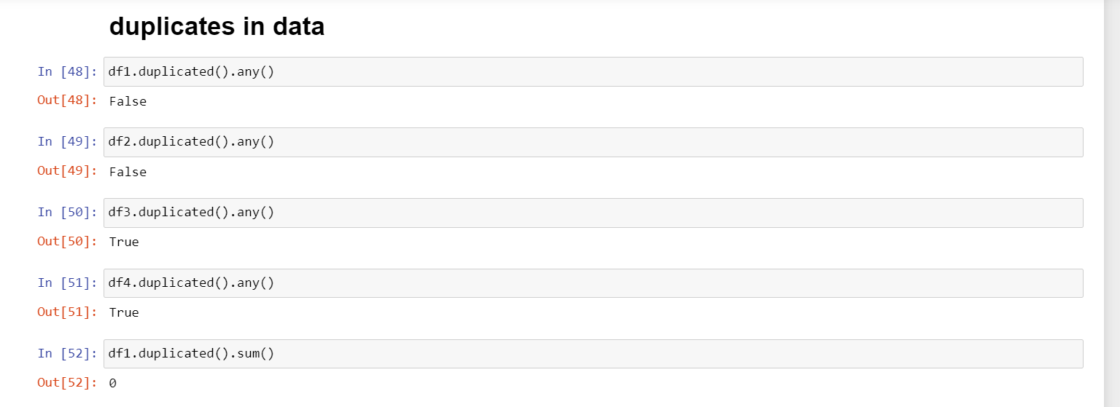

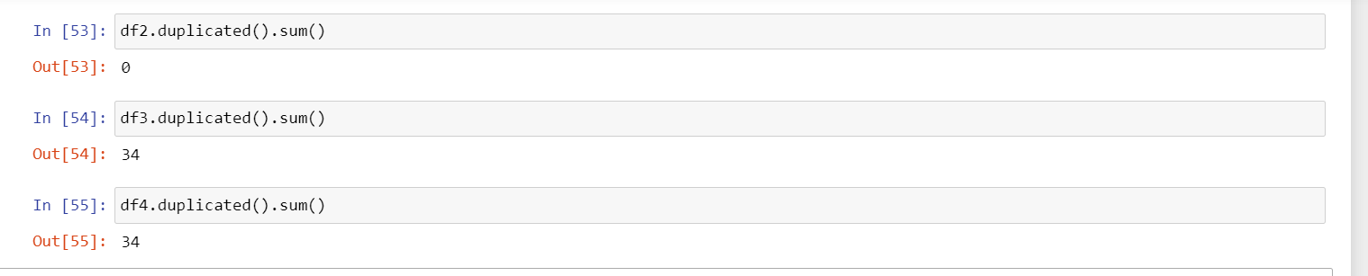

Step: 15 Finding Unique Values

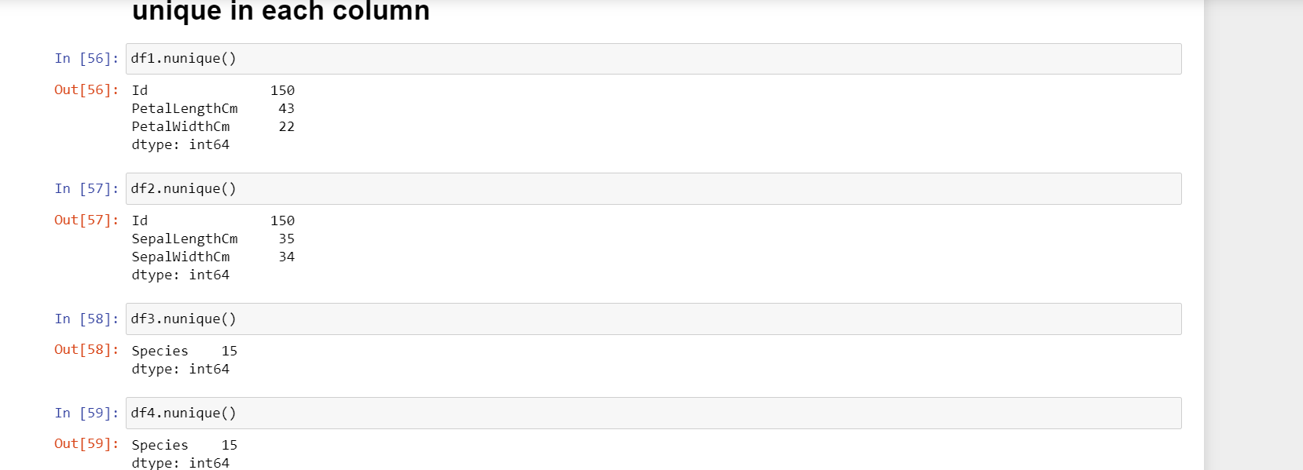

Step: 16 Statistical Analysis Plotting Graphs

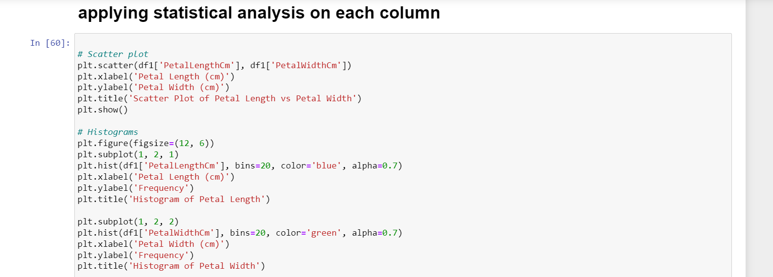

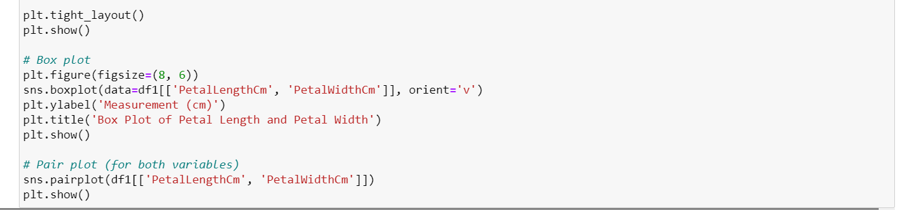

Next Folder Name: iris_cleaning3

Step: 1 Importing Libraries & Connecting to MYSQL

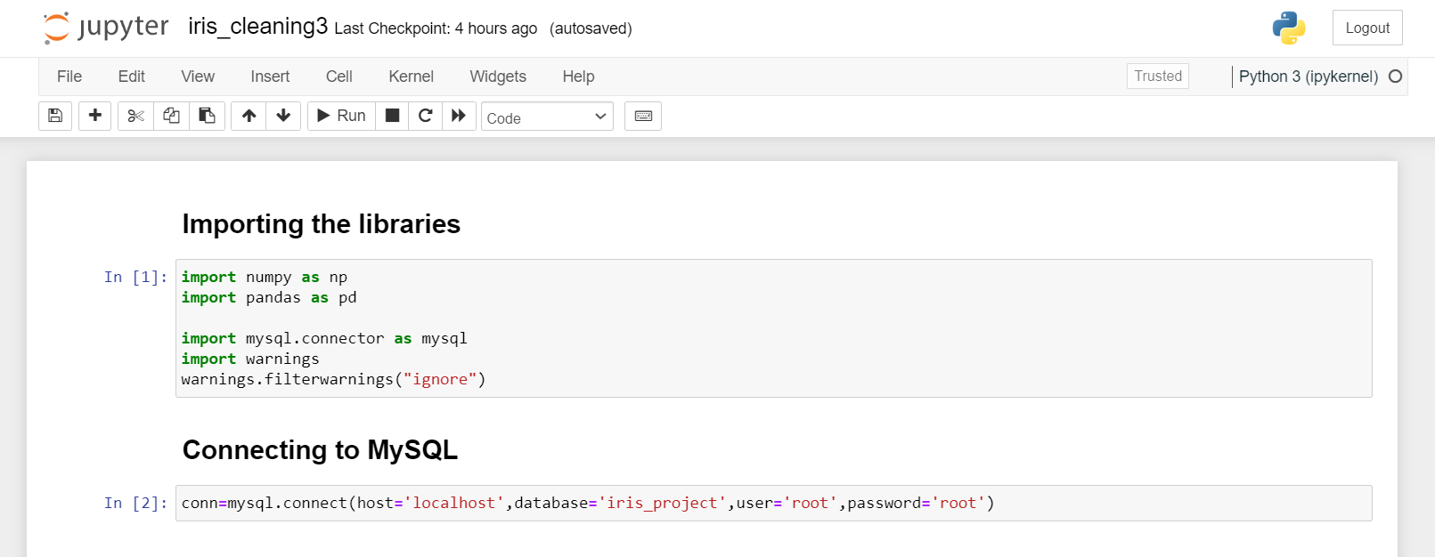

Step:3 Calling Head from MYSQL

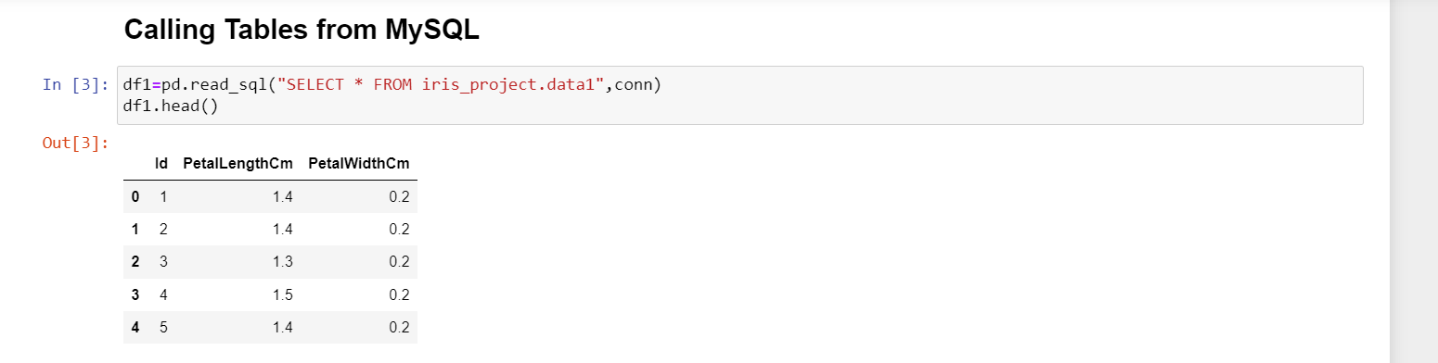

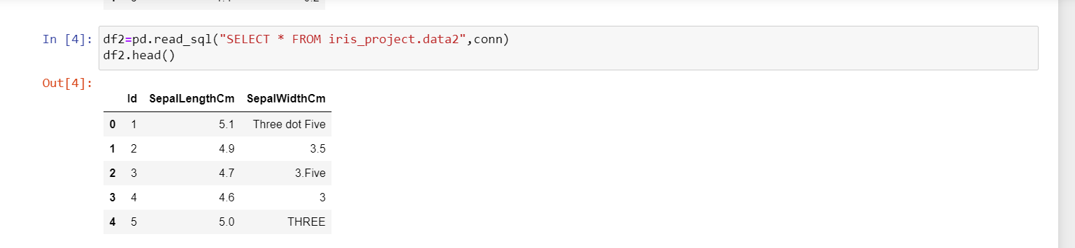

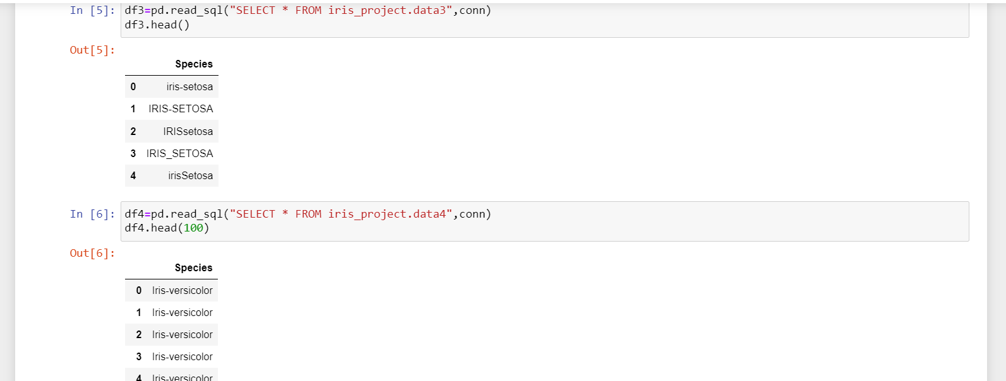

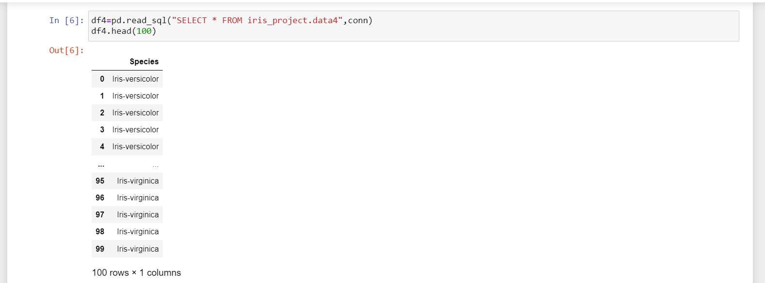

Step: 4 Data Cleaning

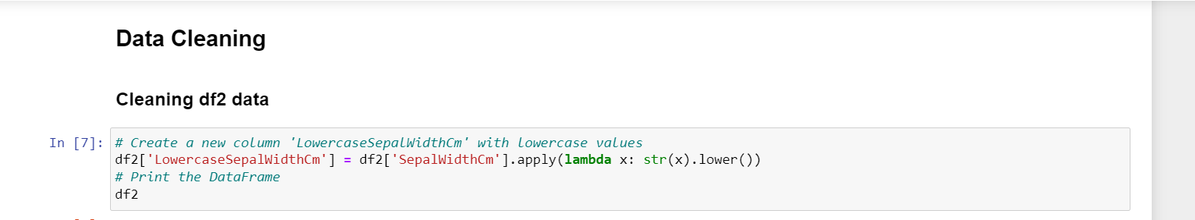

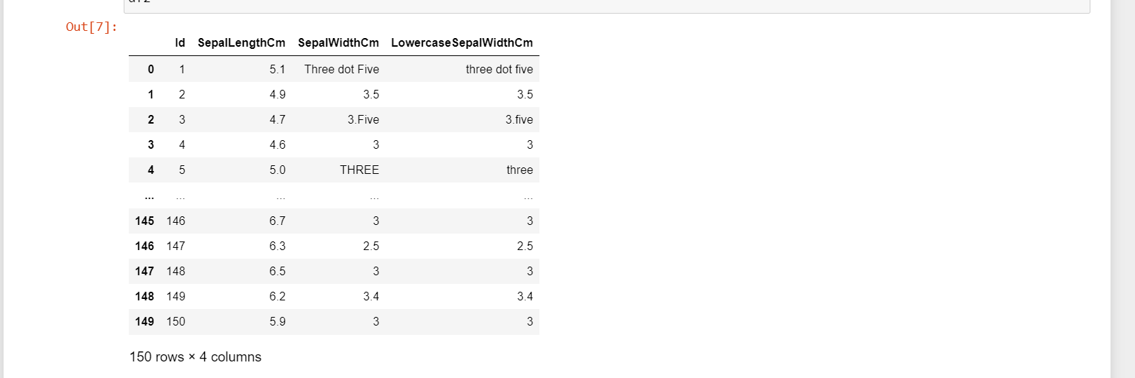

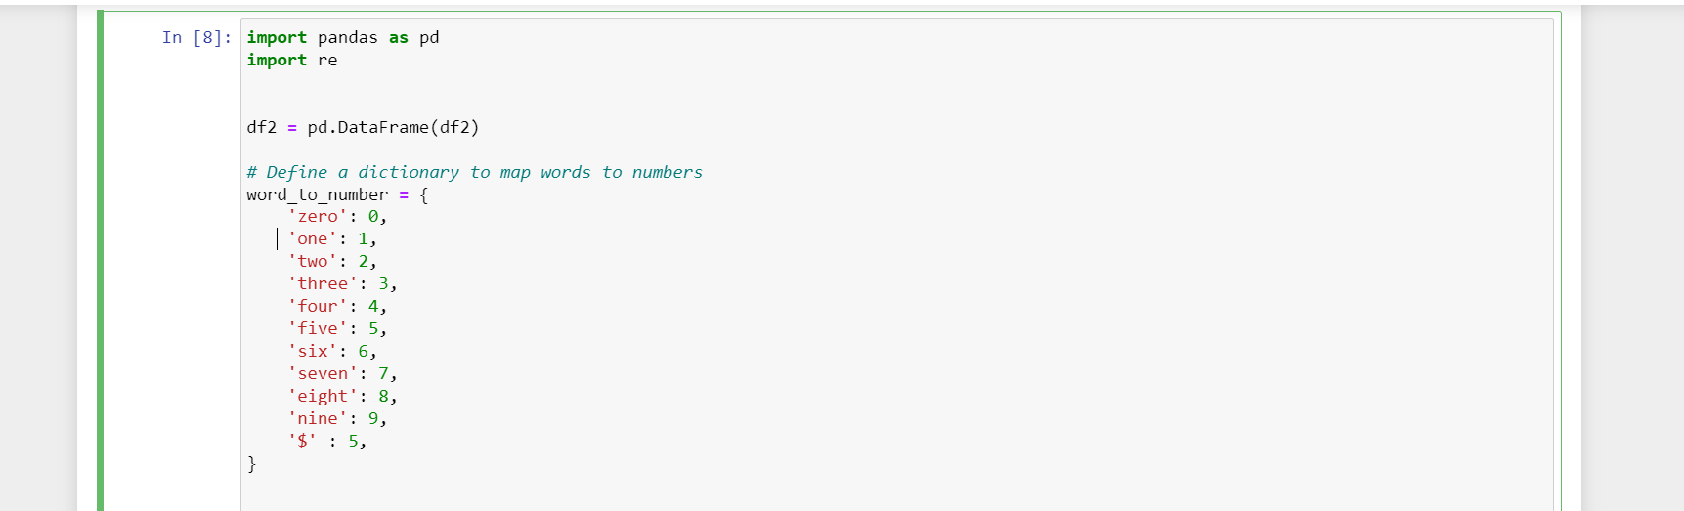

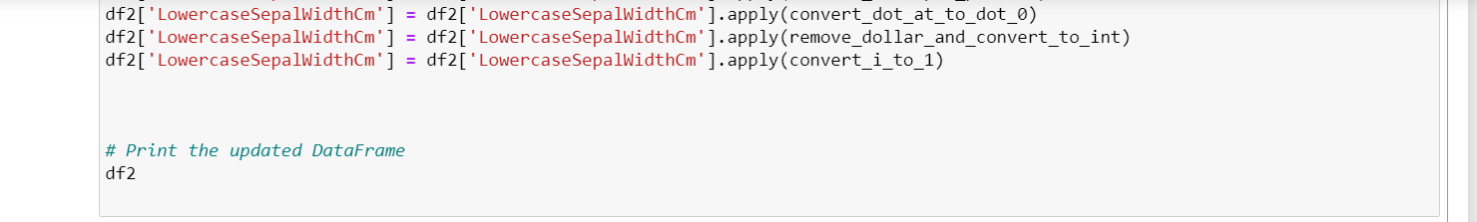

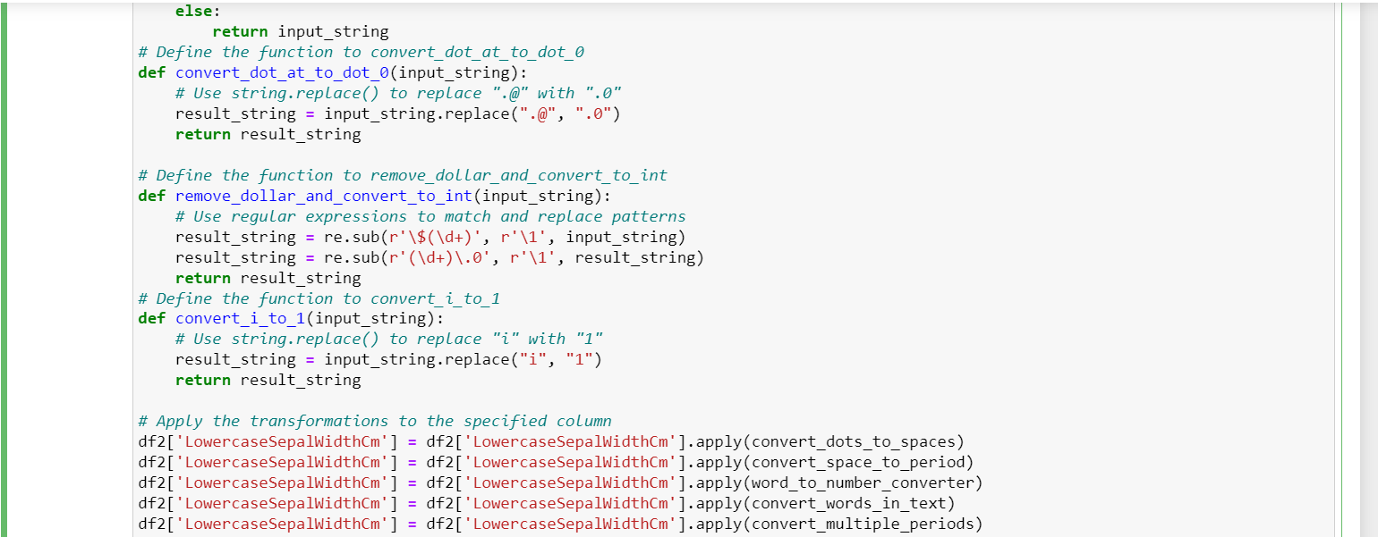



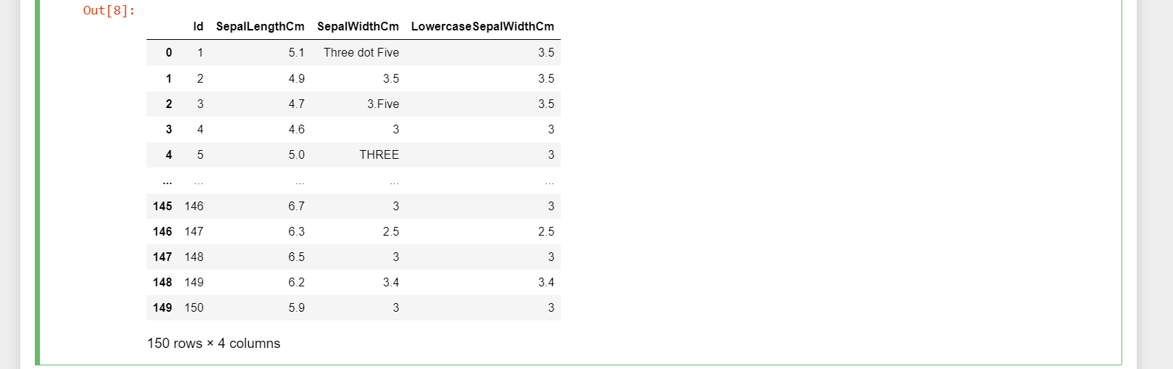

Step: 5 Sepal Width Cm column dropped

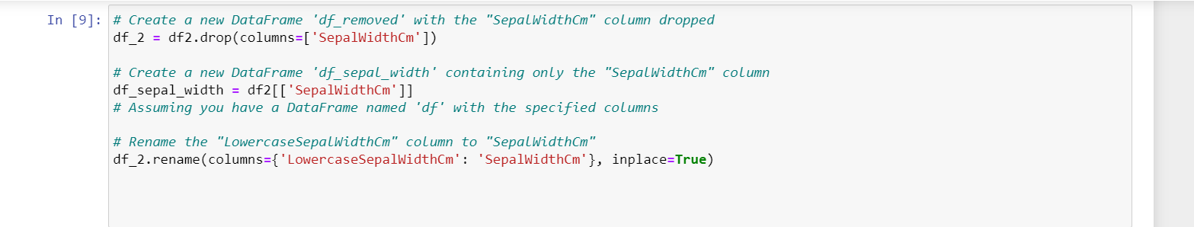

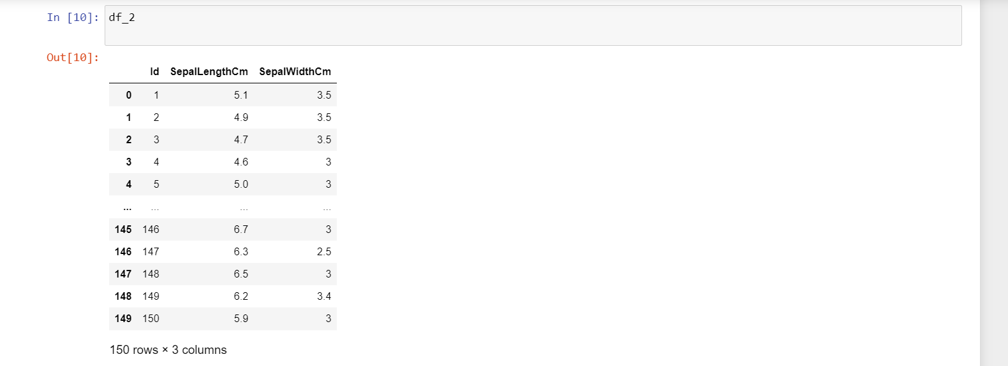

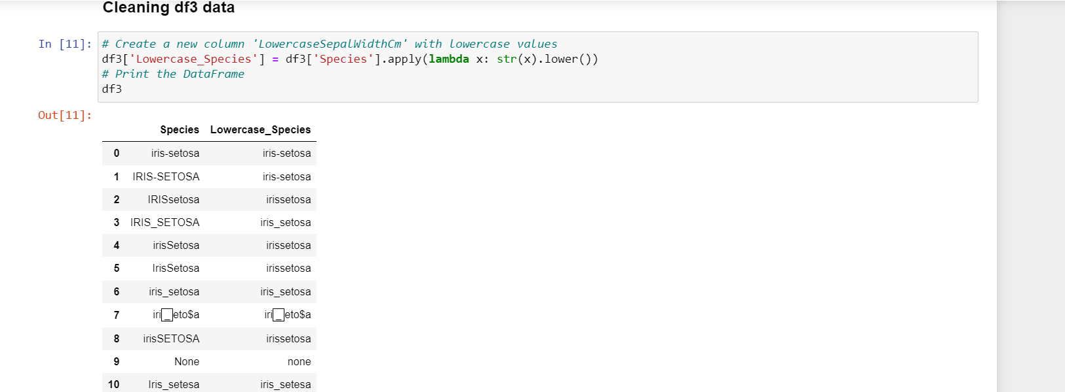

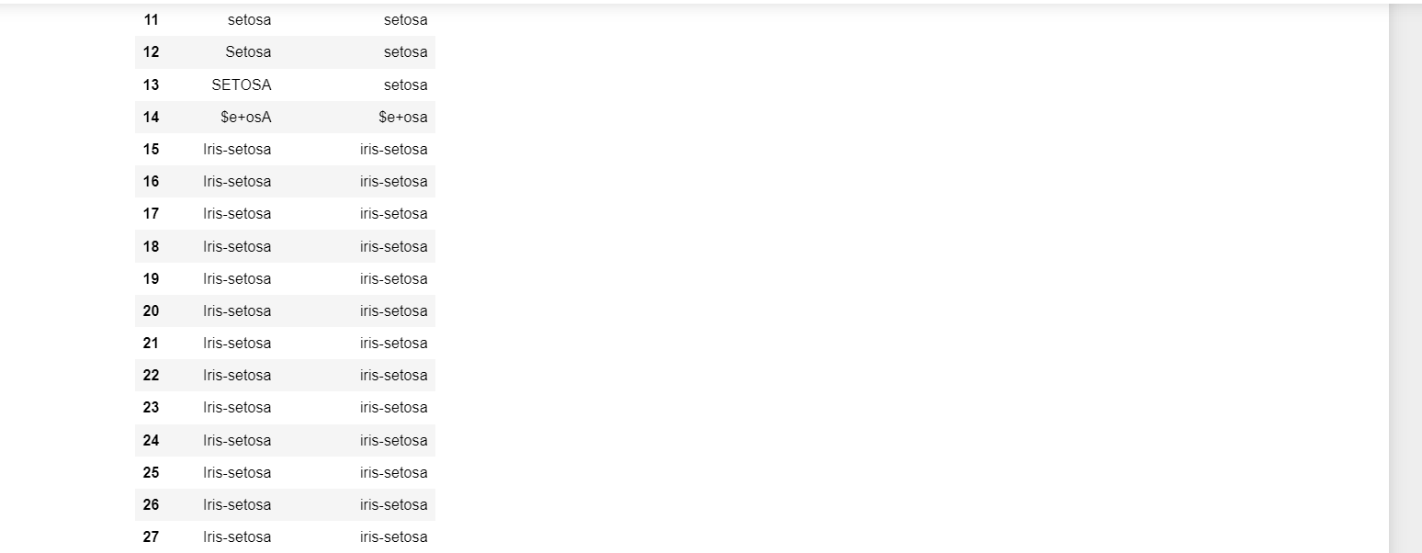

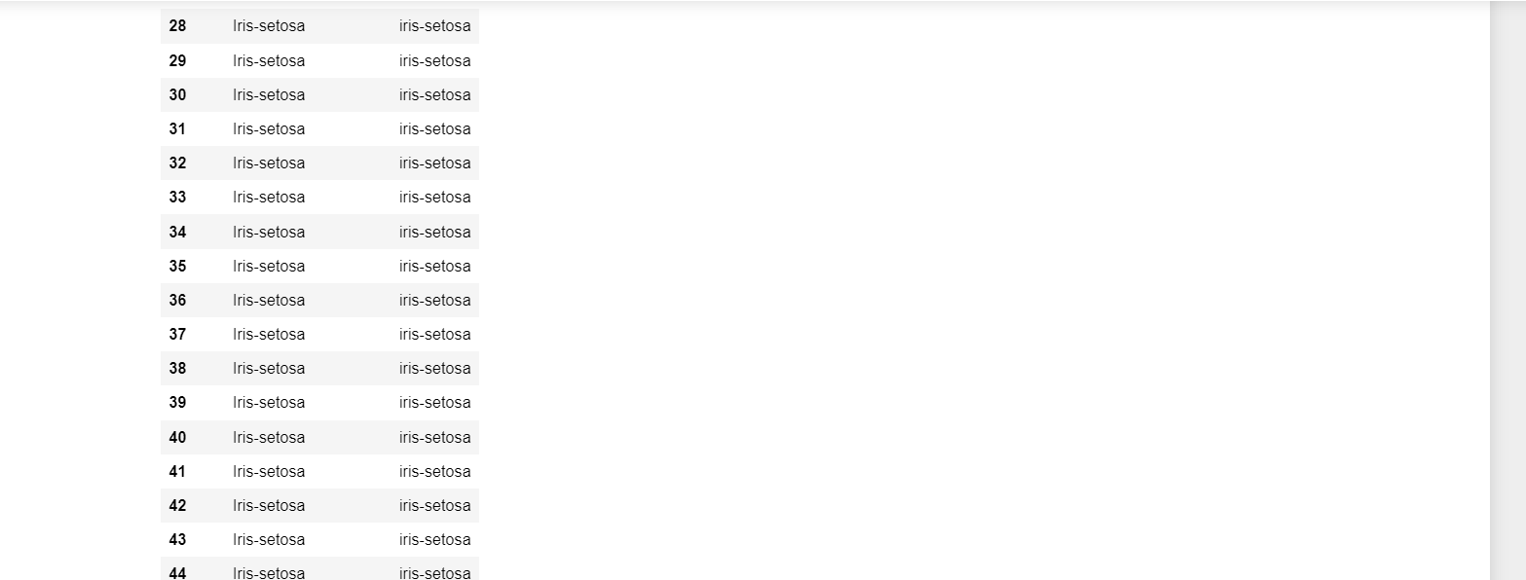

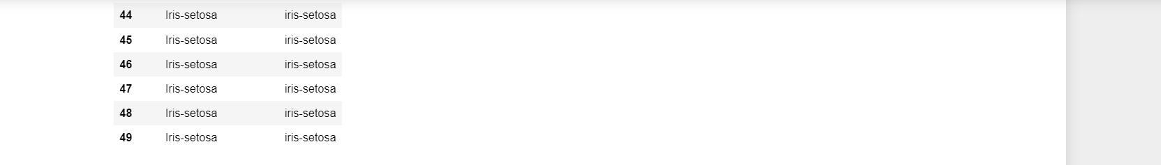

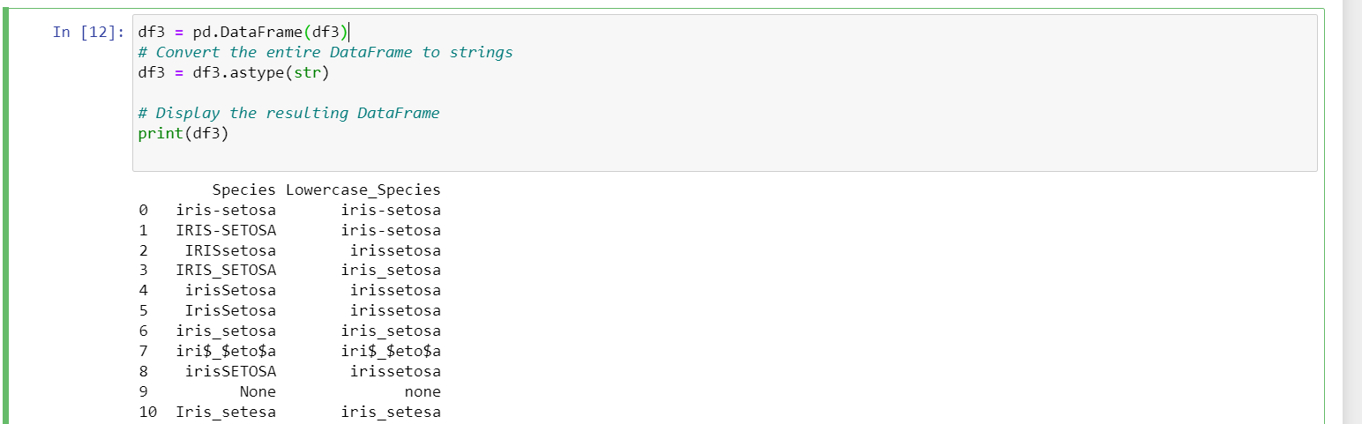

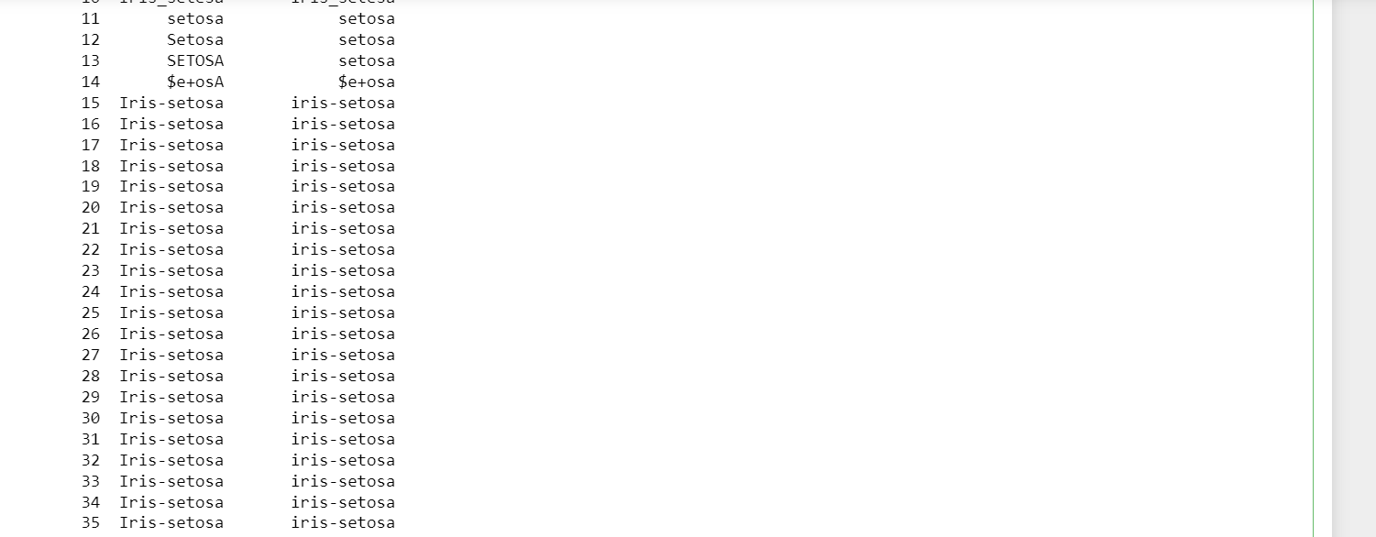

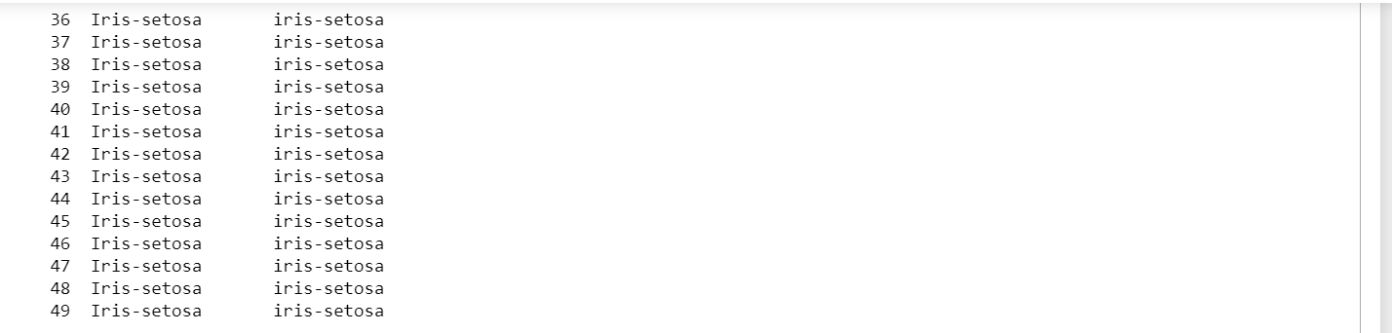

Step: 6 dataset 3 data types

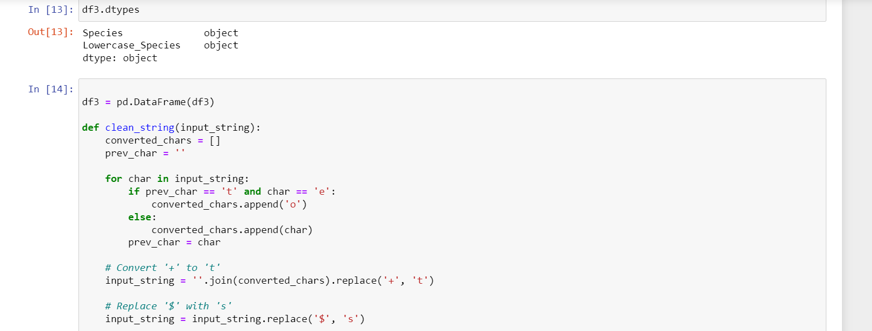

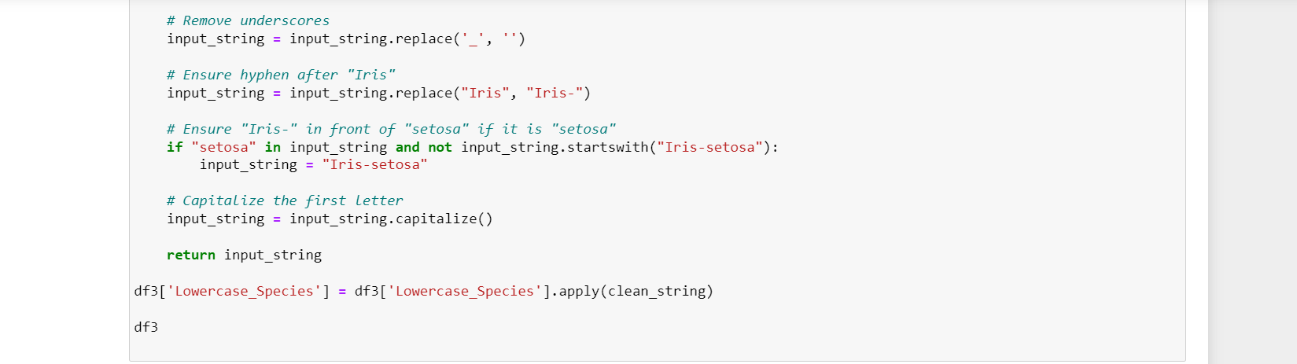

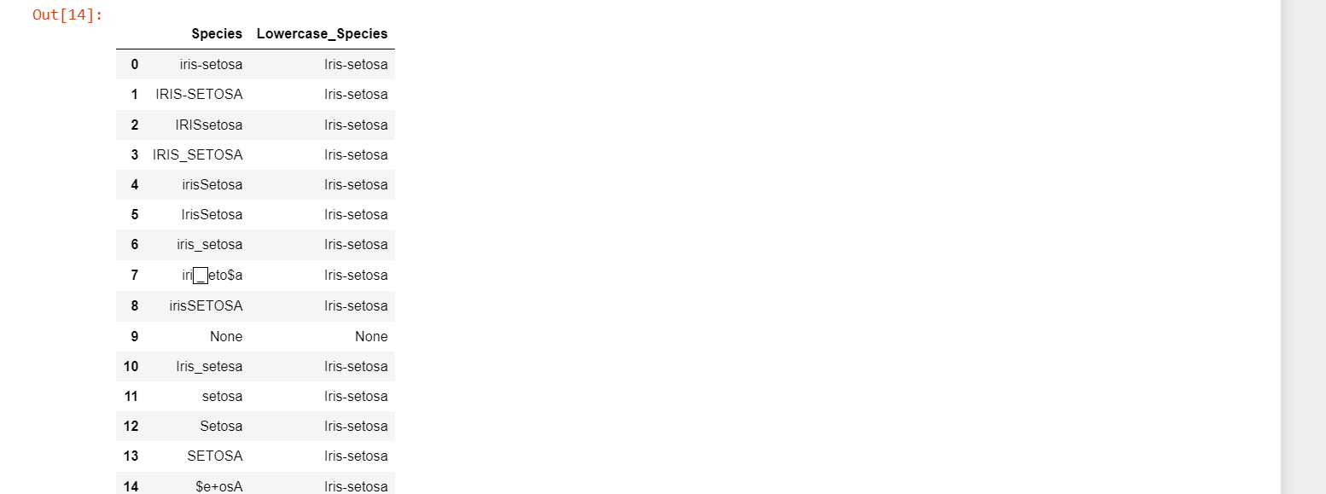

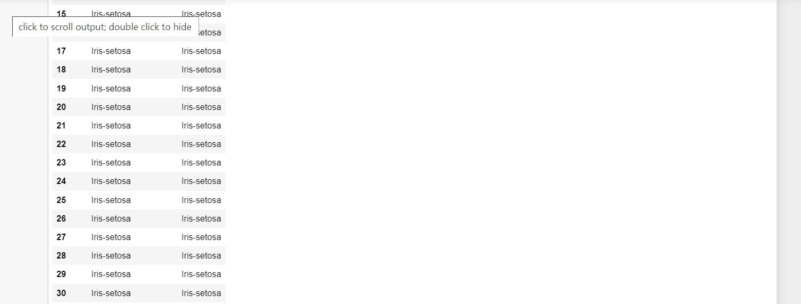

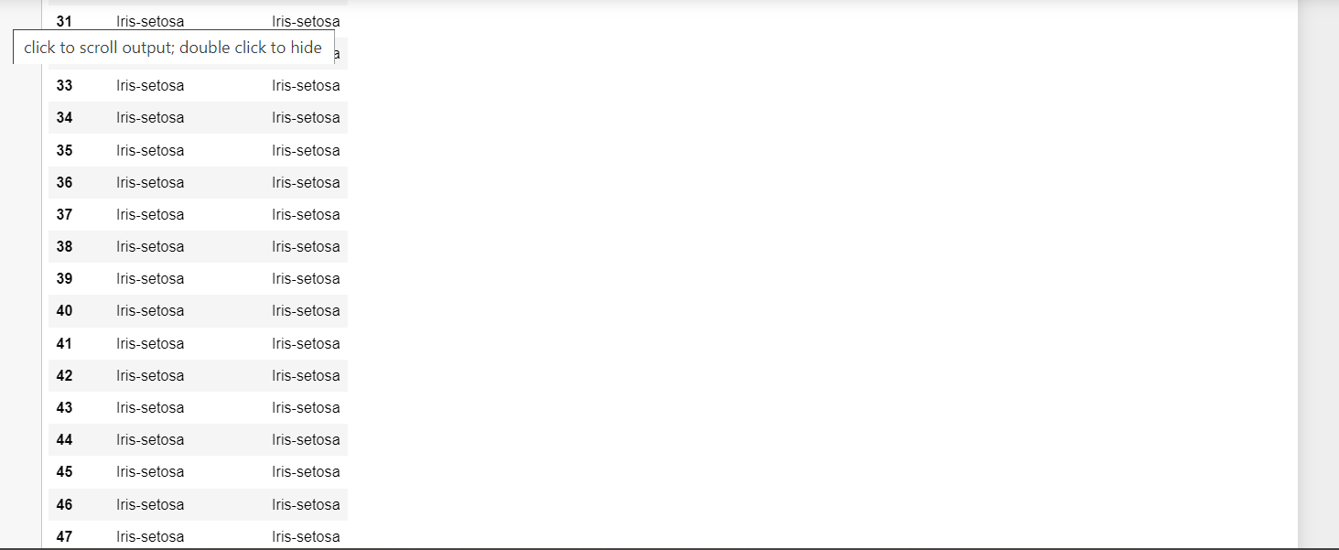

Step: 7 Replacing None with NAN

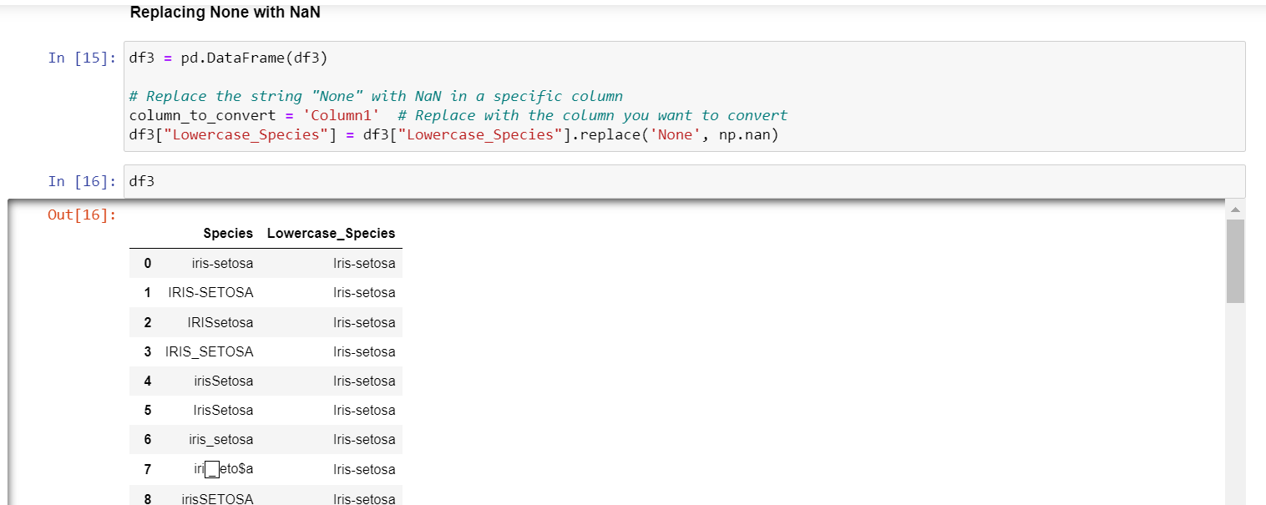

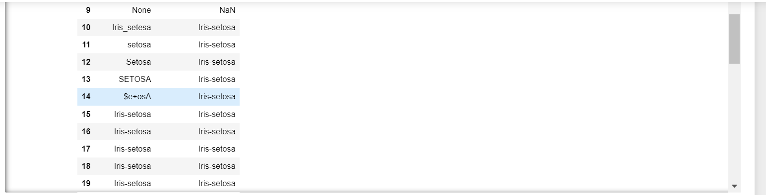

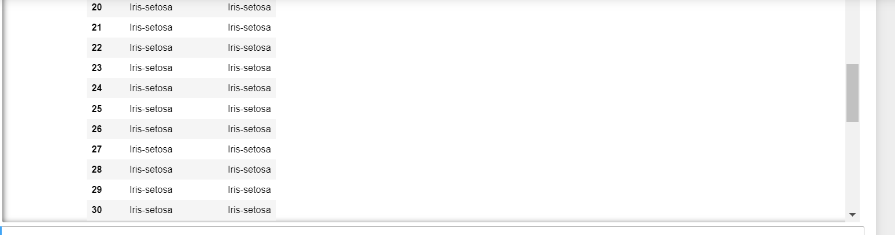

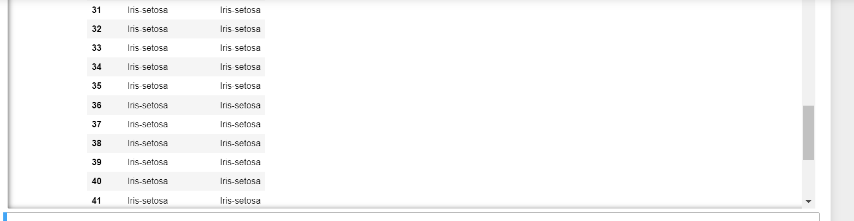

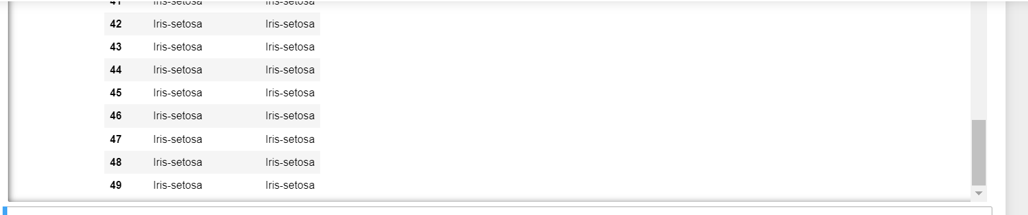

Step: 8 Filling Null Values

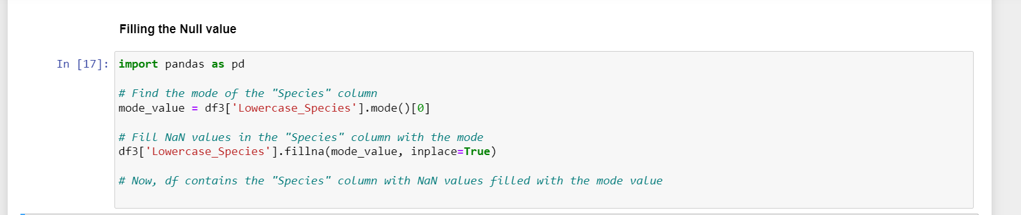

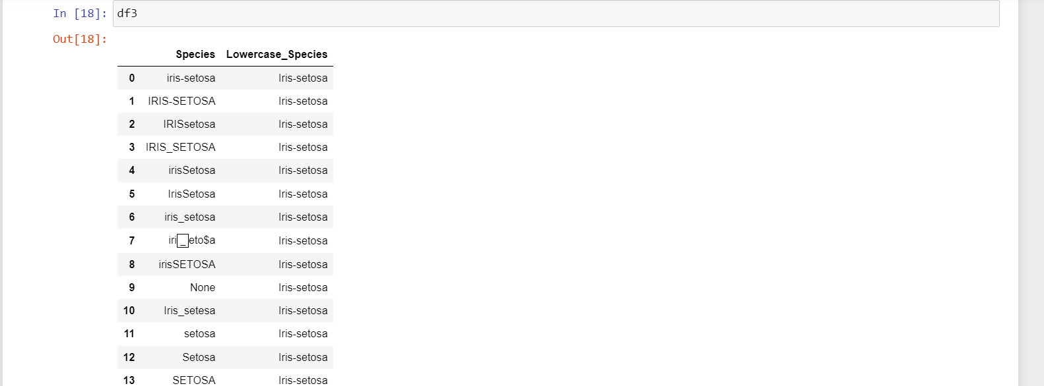

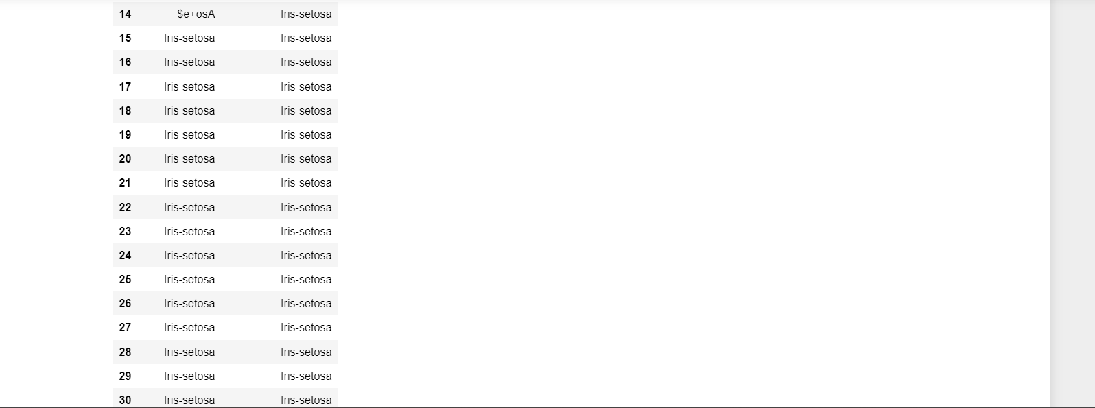

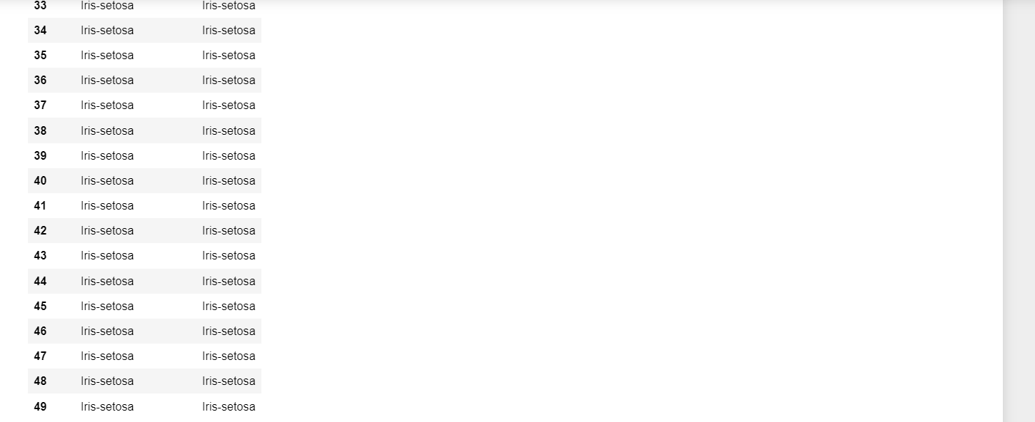

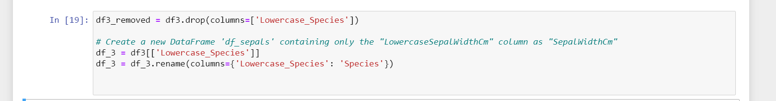

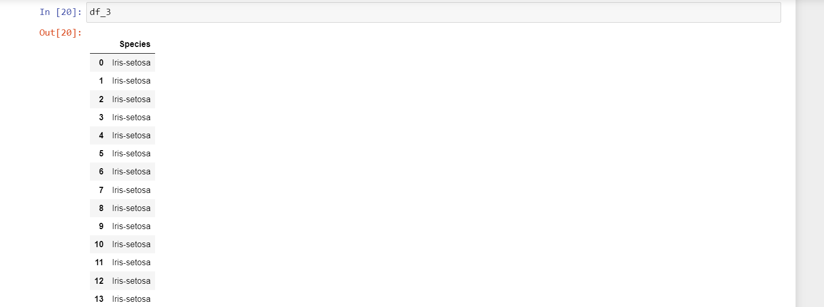

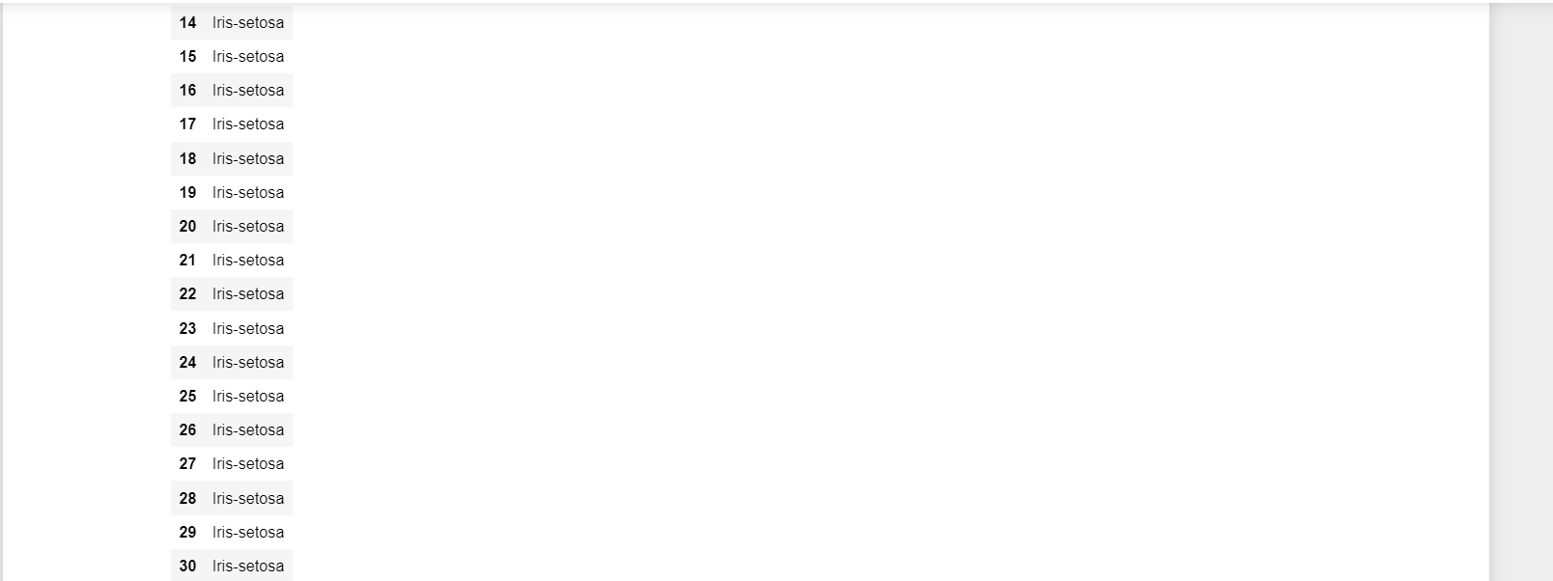

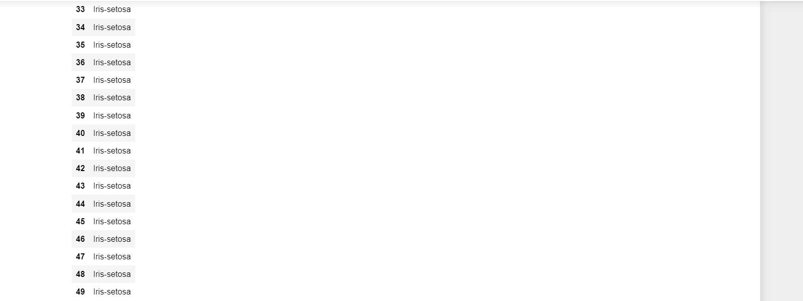

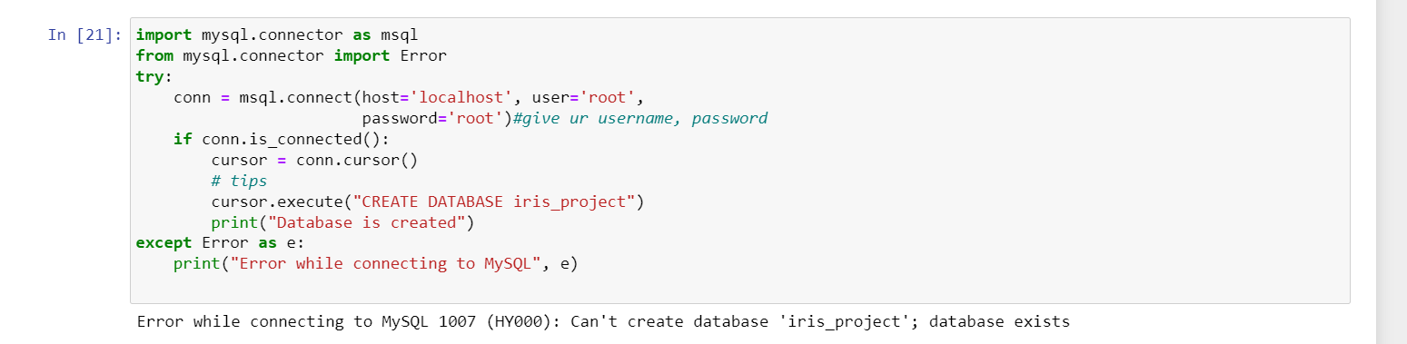



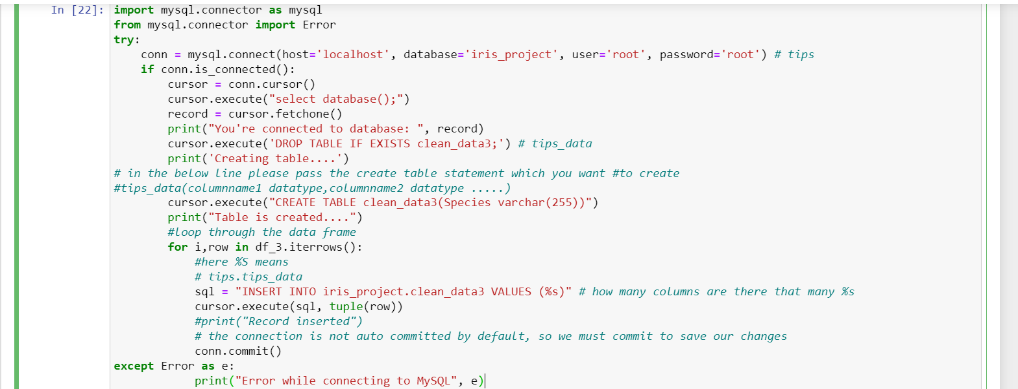



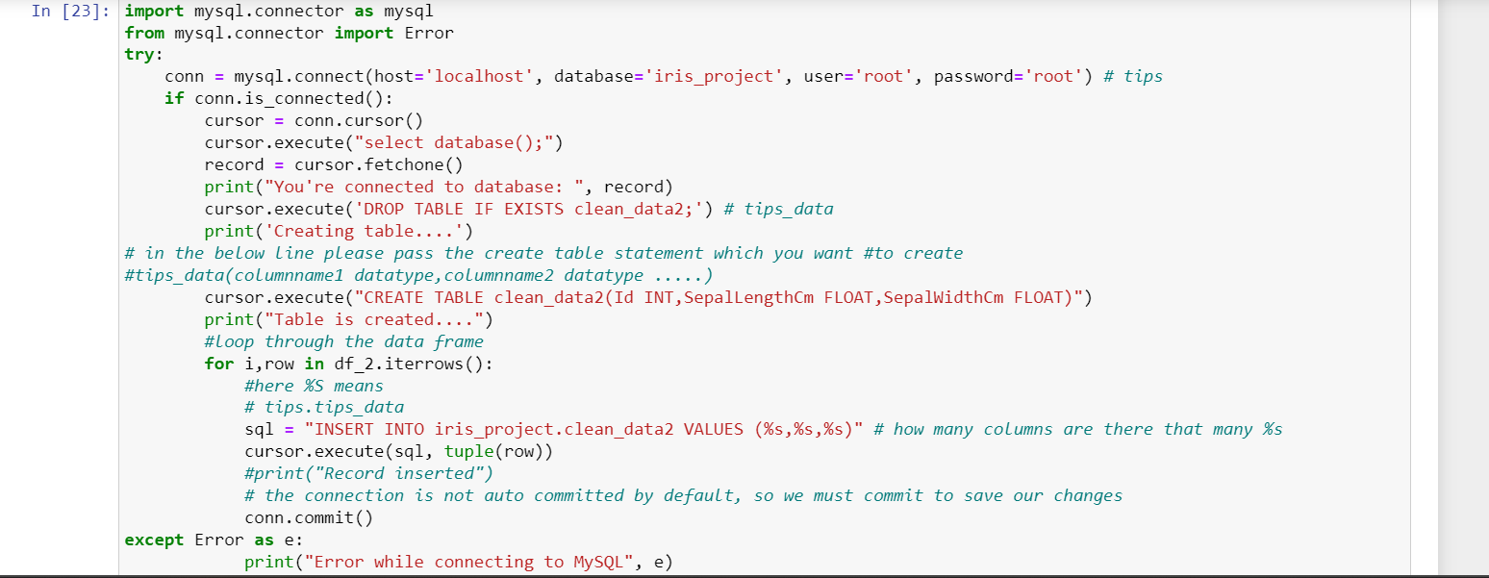



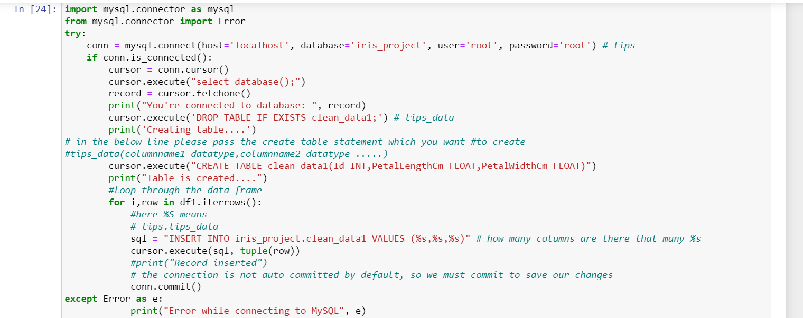



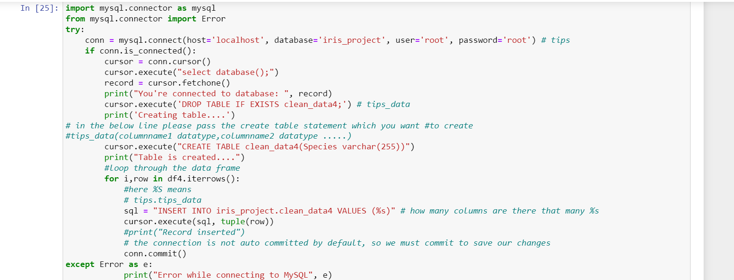



Next folder: Join _merge_concat 4

Step:1 Importing libraries & loading CSV files

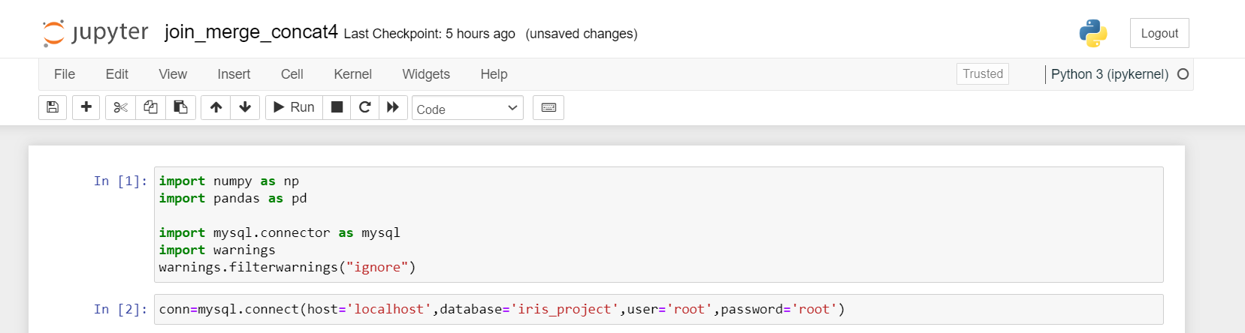

Step:2 Calling clean datasets 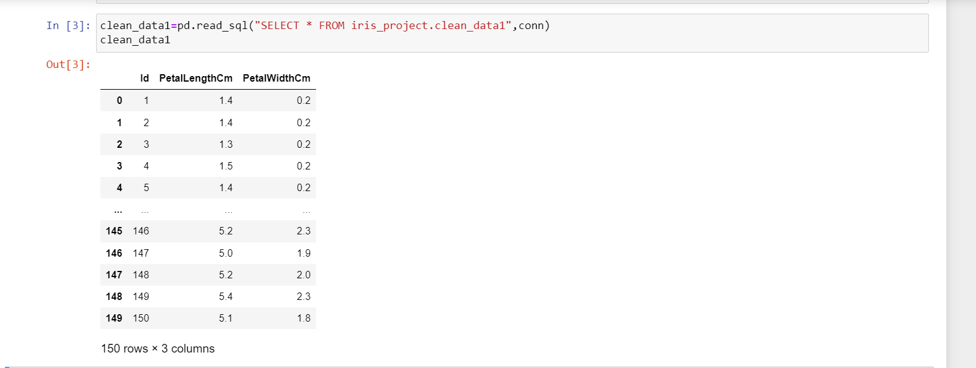

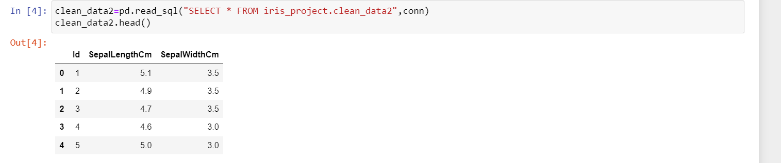

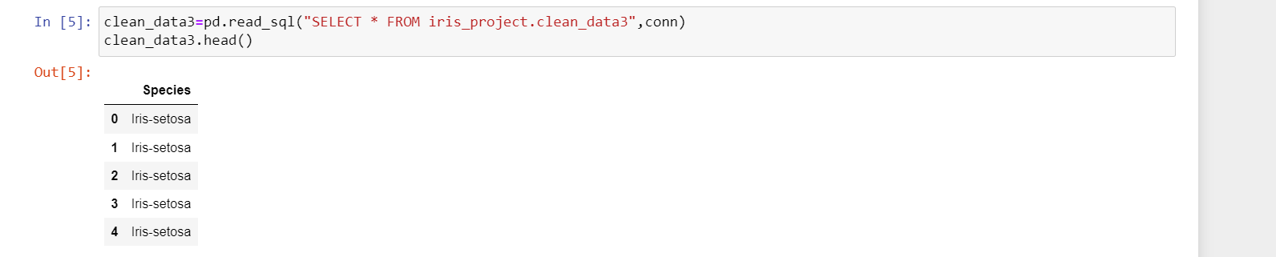

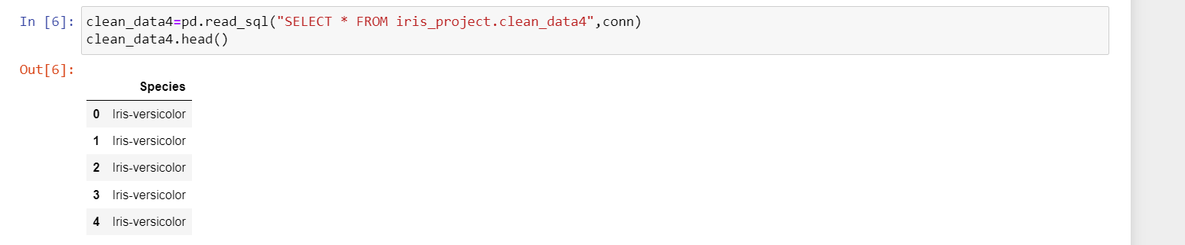

Step: 3 Joining data 1 & data2

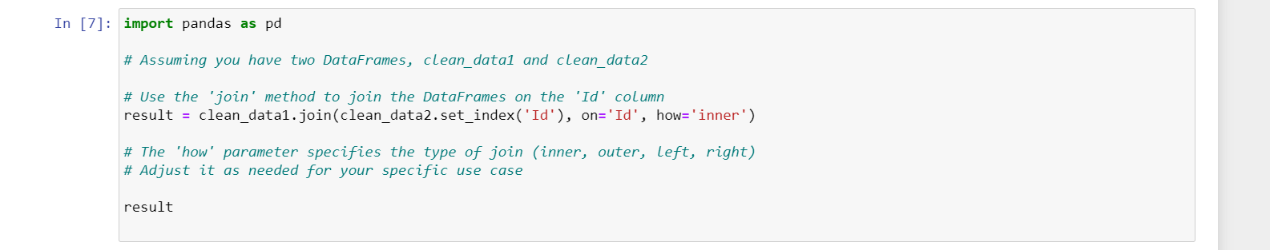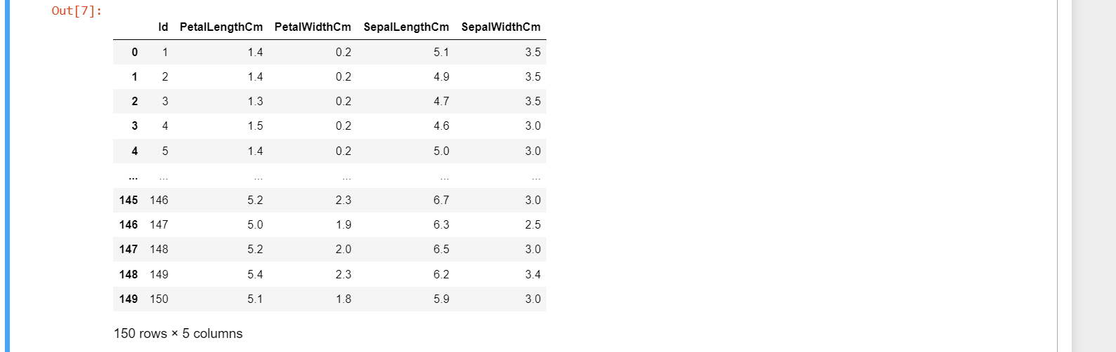

Step:4 Concat data 3 & data4

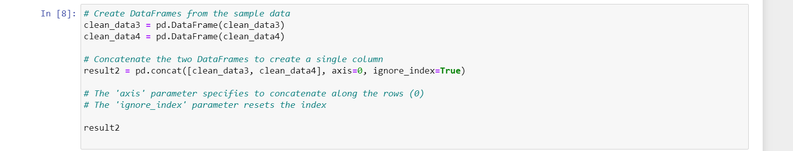

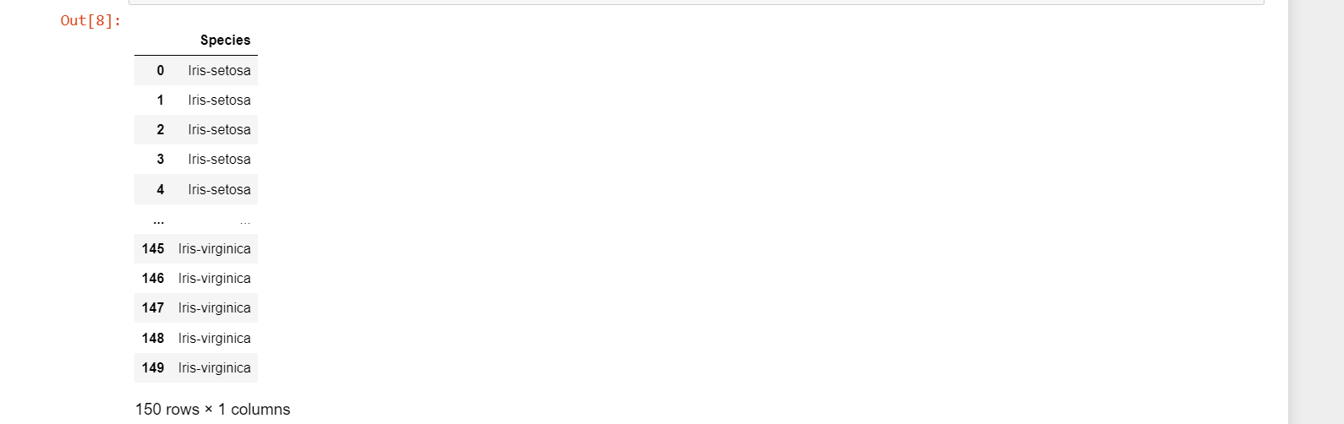

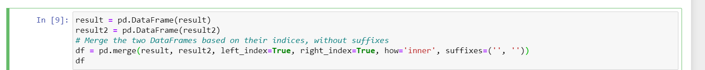

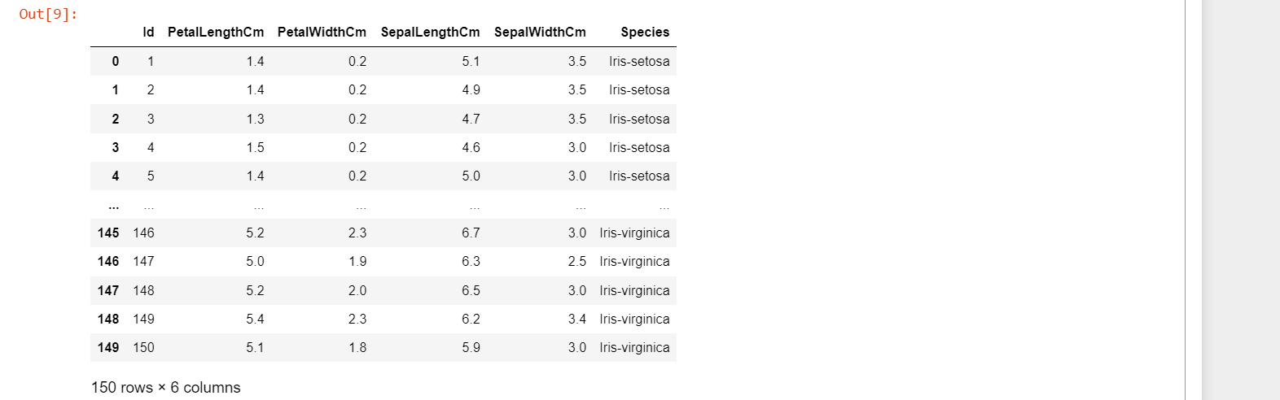

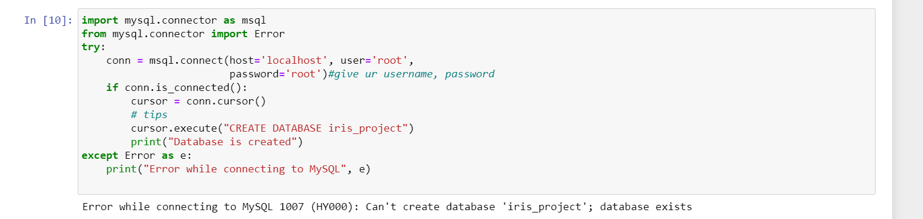

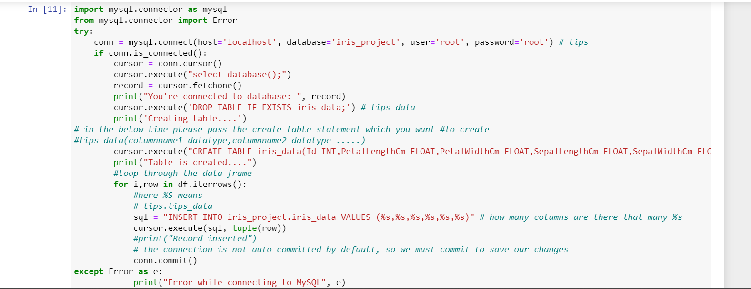



Next Folder: Pre processing after cleaning 5

Step: 1 Importing Libraries 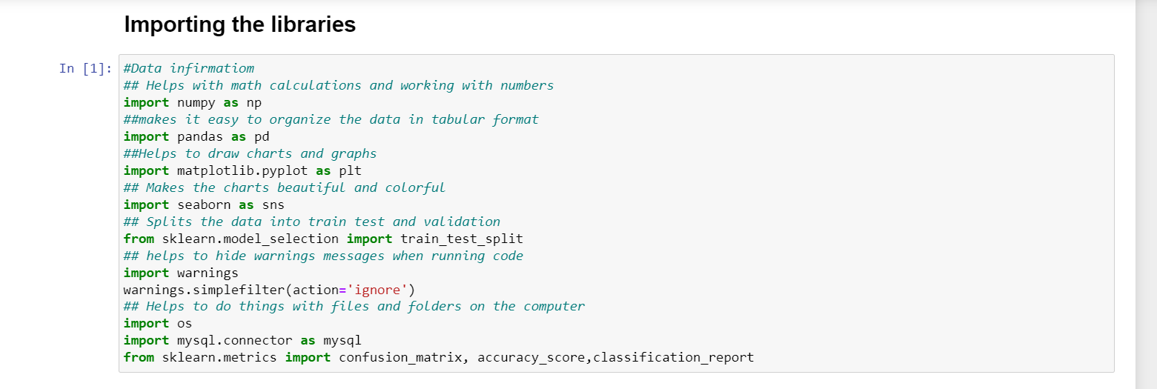

Step: 2 Connecting to MY SQL



Step: 3 Show the created Datasets

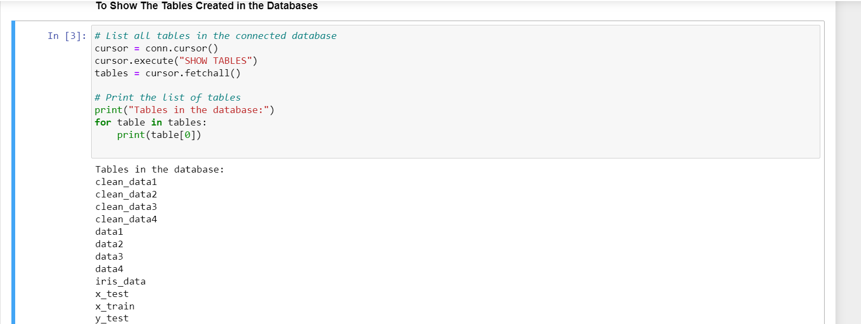

Step: 4 Loading my SQL data



Step : 5 Head

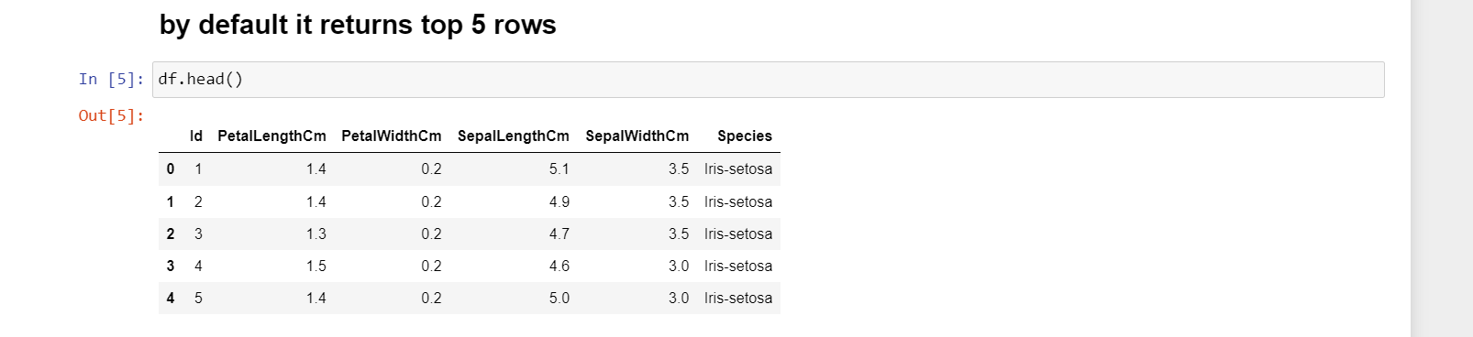

Step: 6 Tail

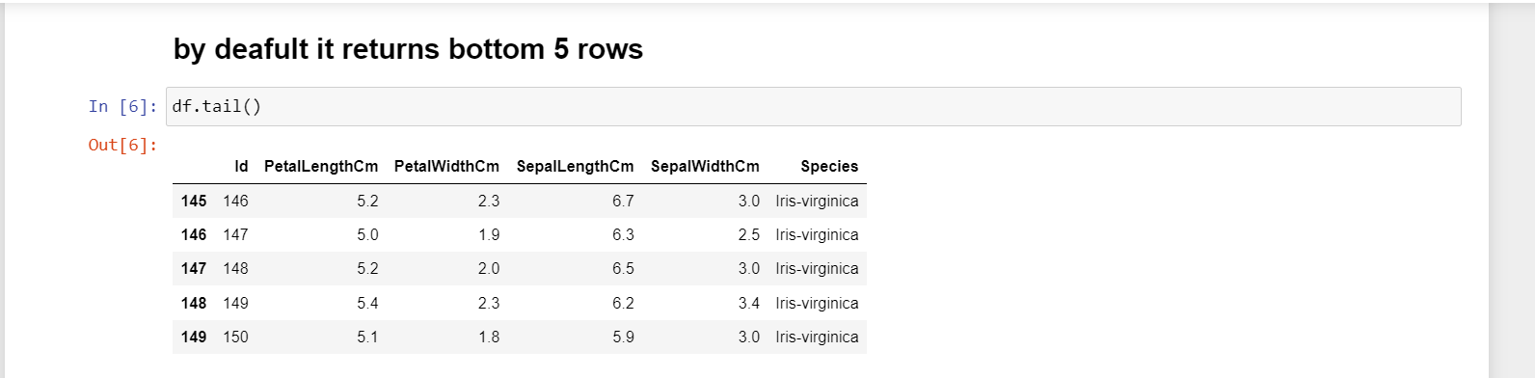

Step: 7 Shape of Columns & Rows

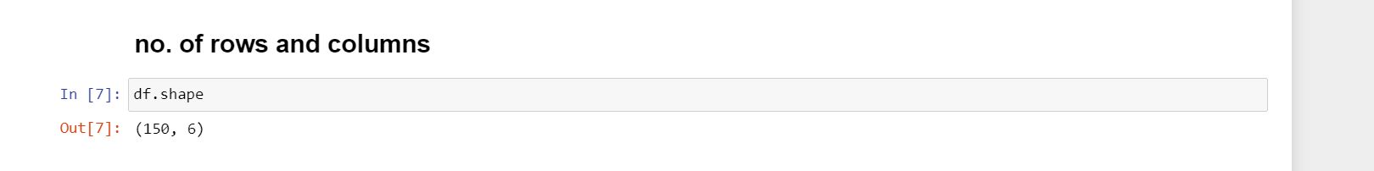

Step: 8 Statistical Analysis of Data

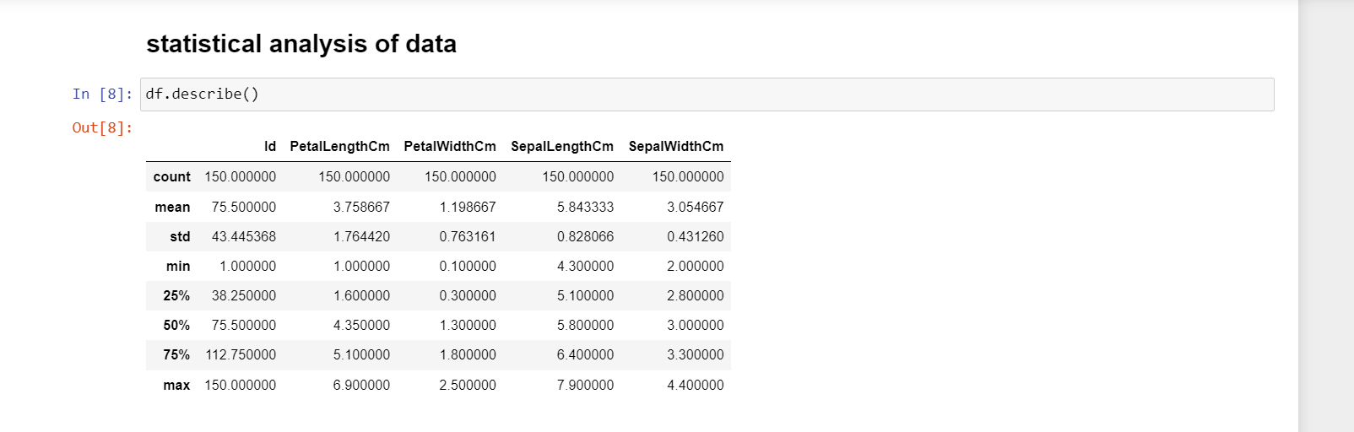

Step: 9 Data type of the Dataset & Information of each column

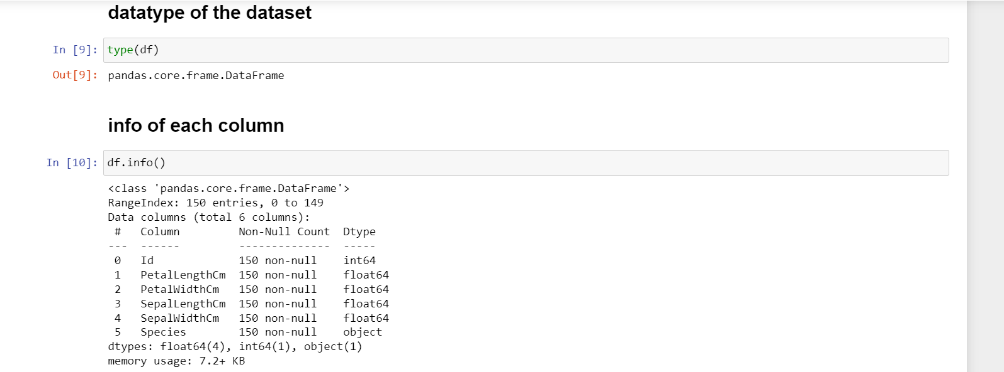  
Step: 10 Displaying Columns of dataset & Count of the data

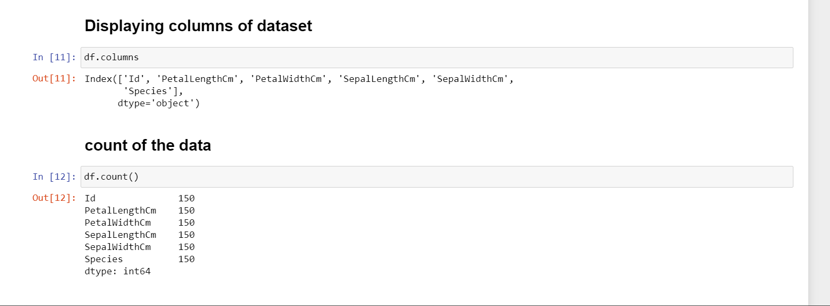

Step: 11 Finding Null Values & Data type of each column

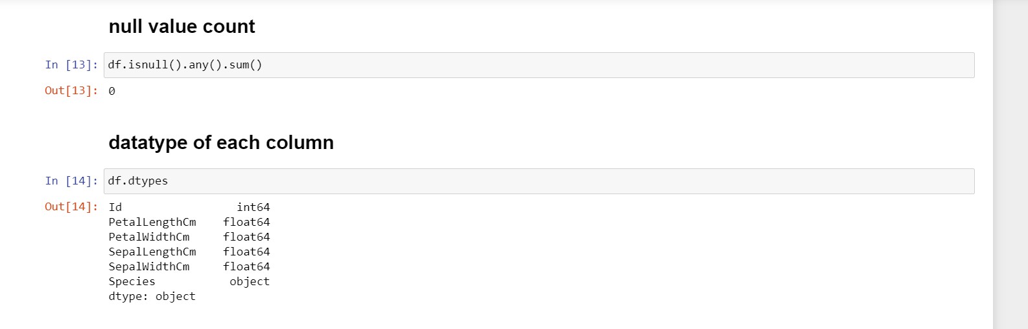

Step: 12 D type of specific column ,No. of dimensions & Finding duplicates in data

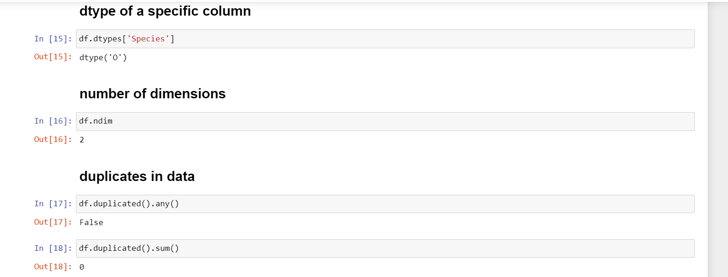

Step: 13 Finding Unique in each column

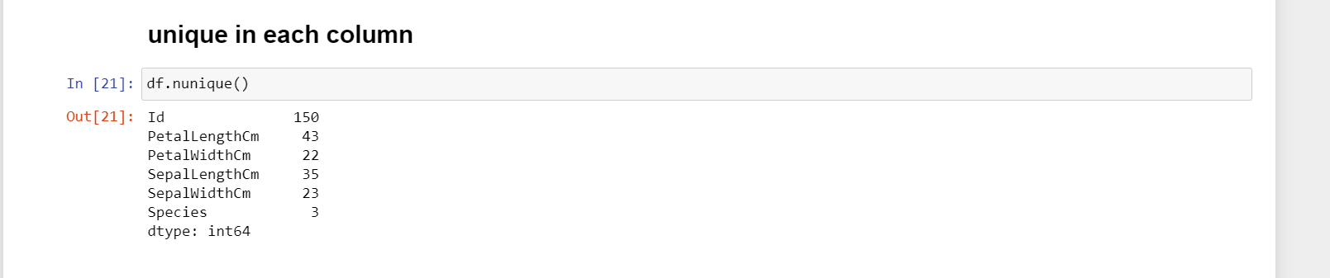

Step: 14 Saving continuous data in new variable name



Step: 15 Quantitative Data Distribution Statistics Analysis

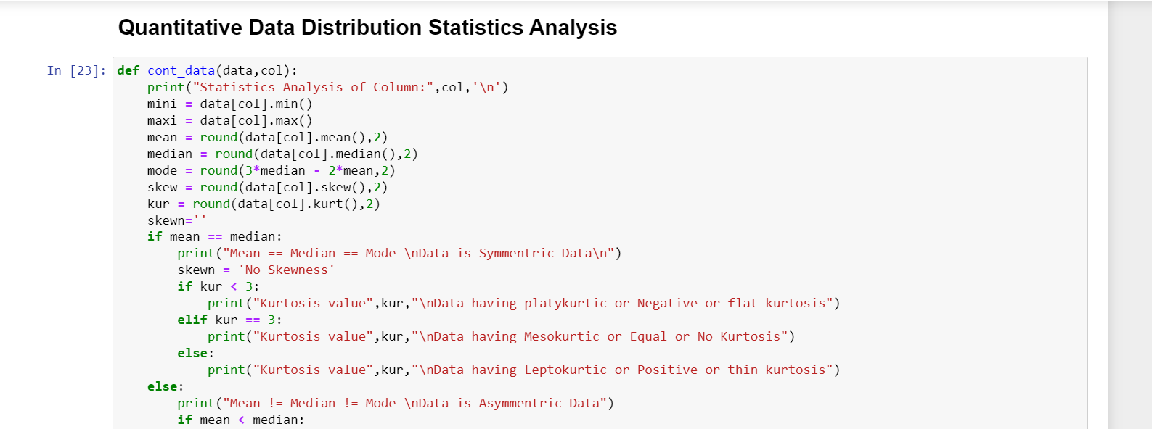

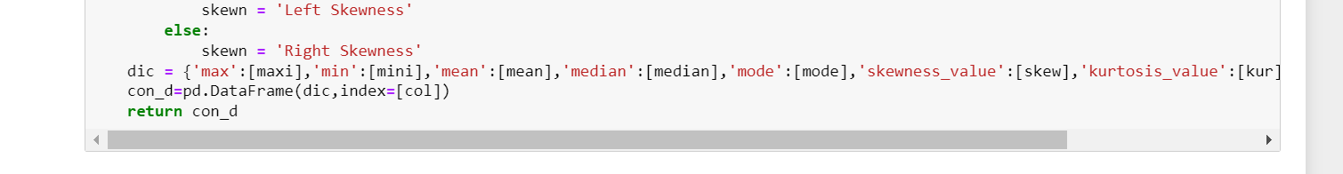

Step :16 Applying Statistical Analysis on each column

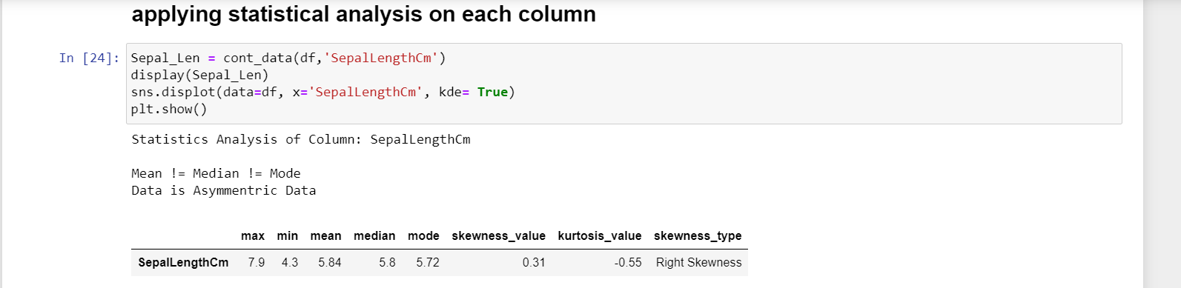

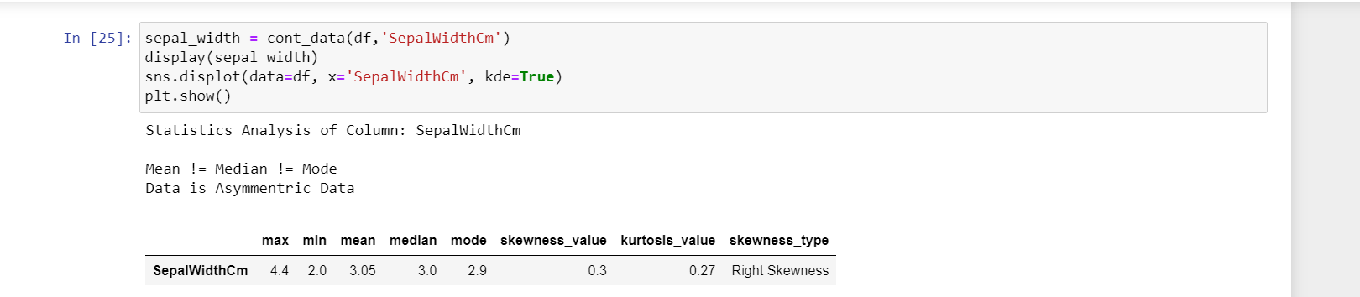

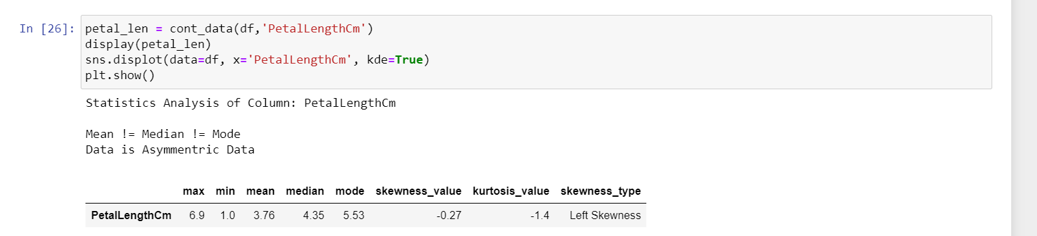

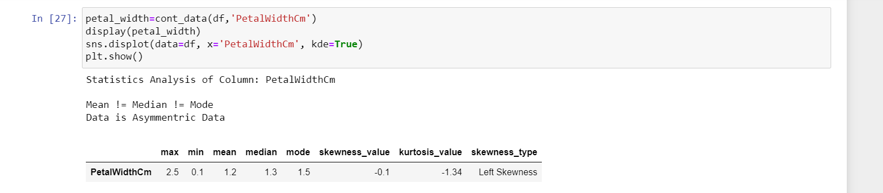

Step: 17 Creating function for Qualitative Data Distribution

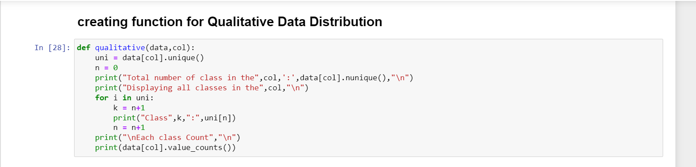

Step: 18 Applying on Categorical data

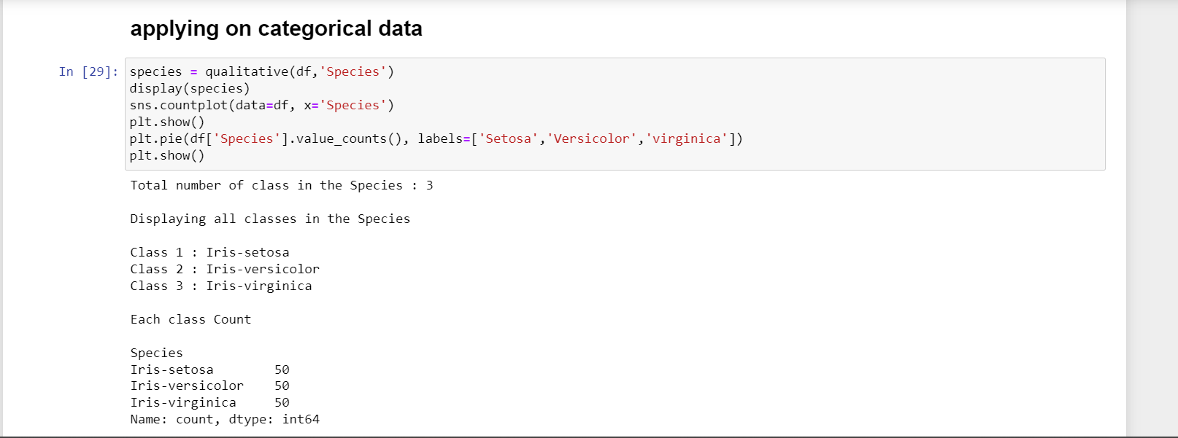

Step: 19 Outliers

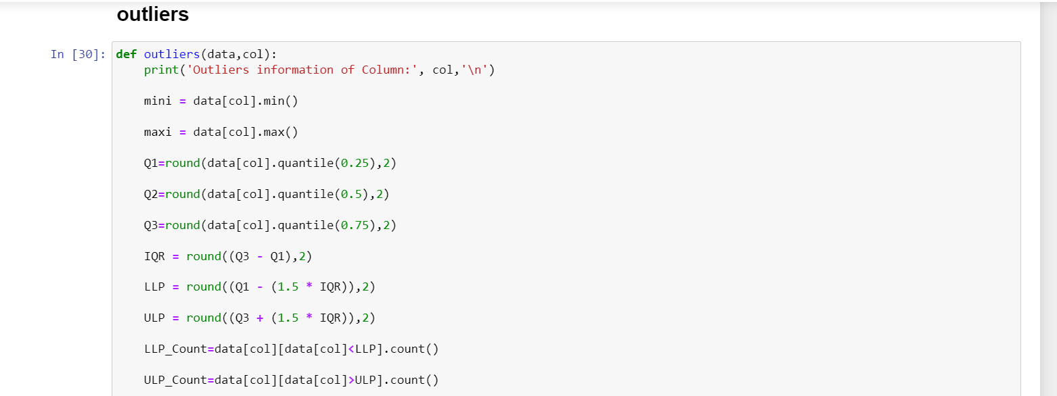

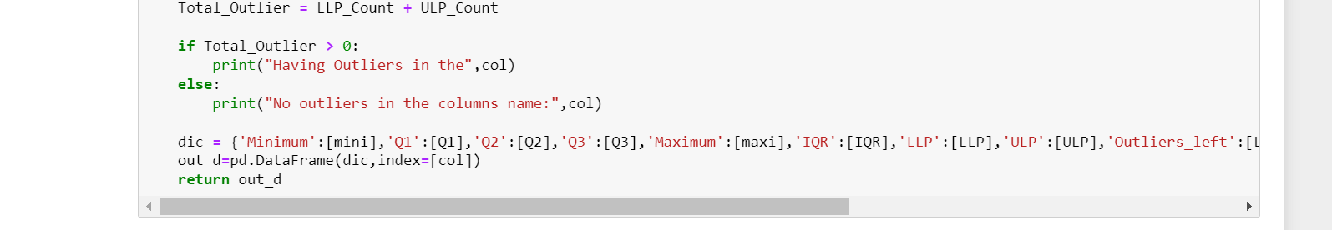

Step : 20 Finding outliers in each column

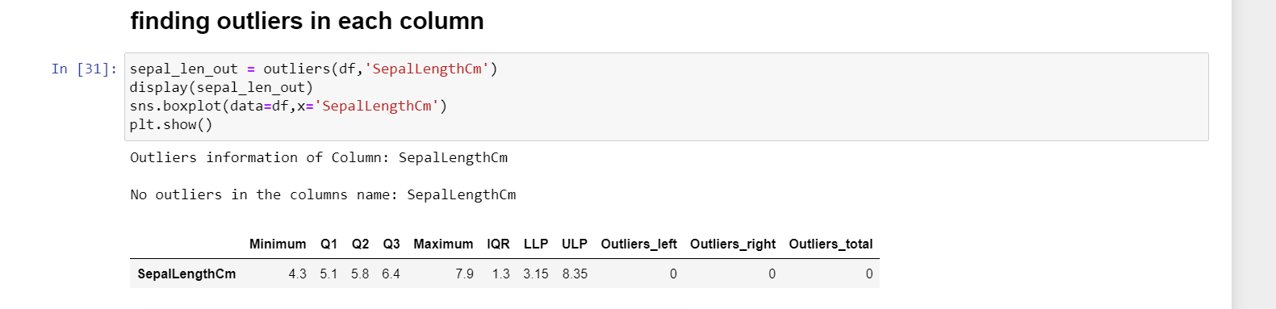

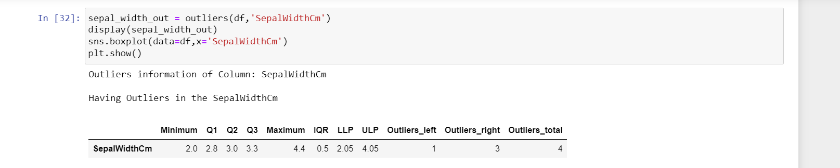

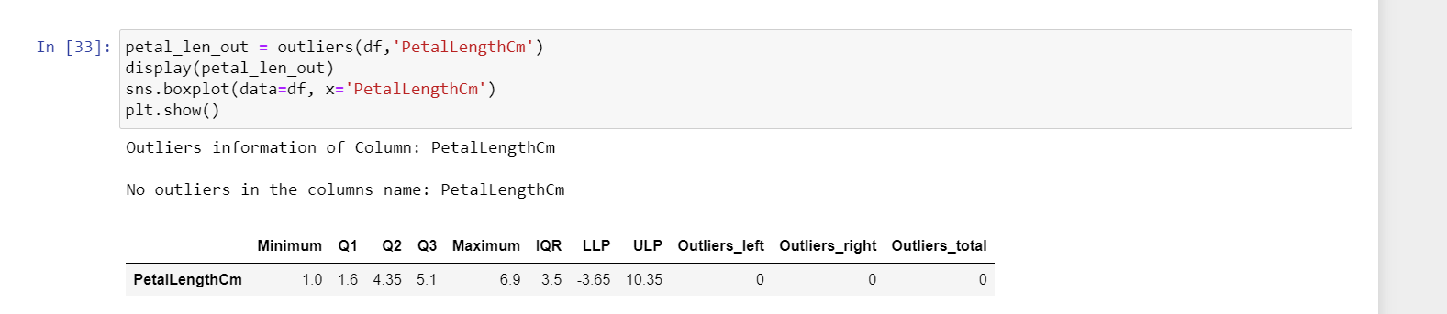

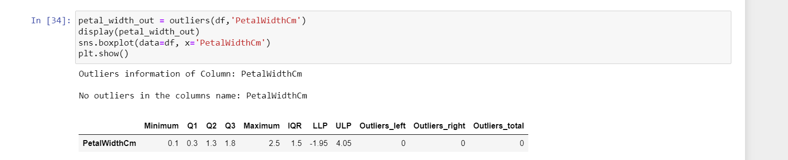  
Step: 21 Label Encoding

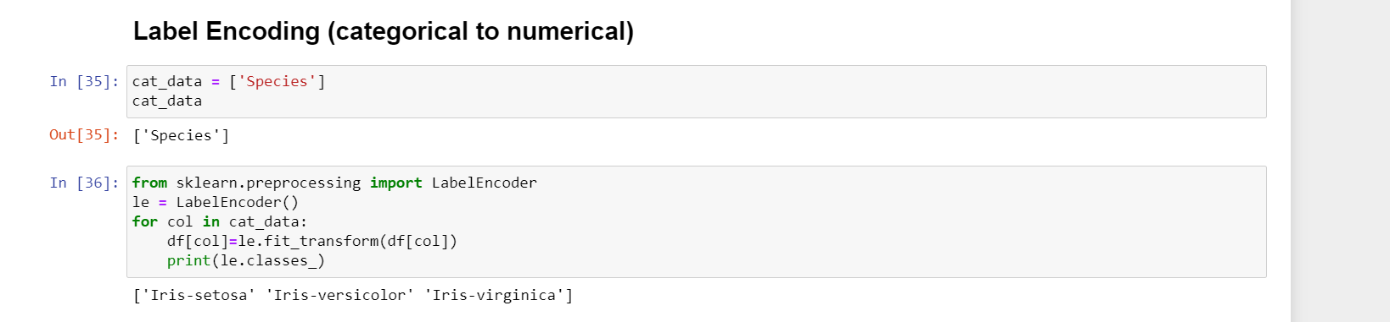

Step: 22 Head

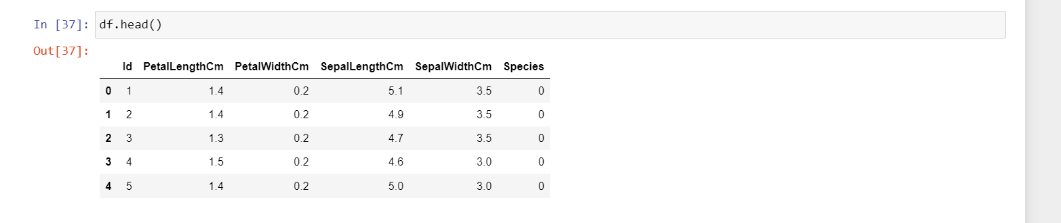

Step : 23 Converting df to csv as clean data

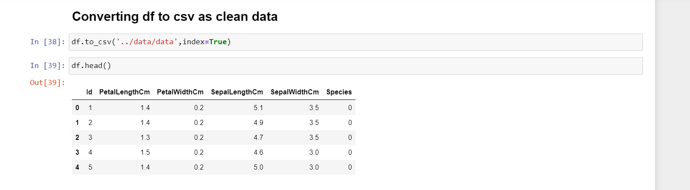

Step: 24 Defining Function For Corelation

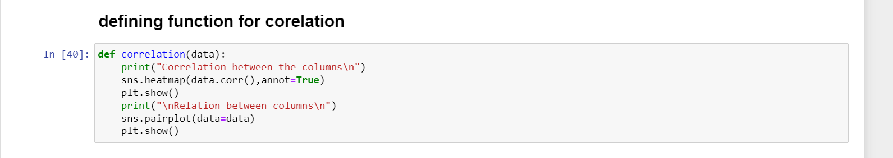

Step: 25 Applying only on continuous data

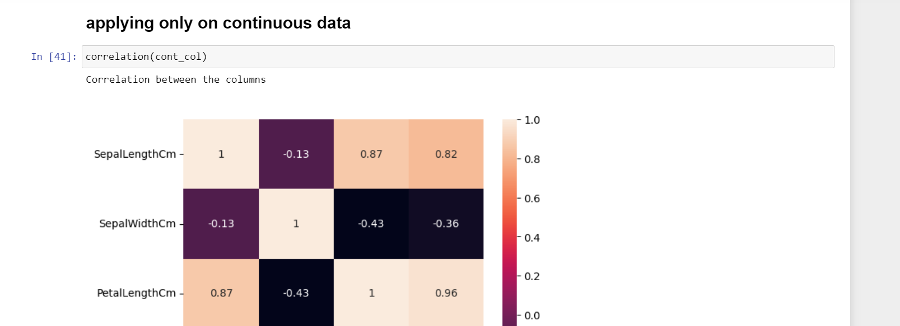  
Step: 26 Defining fun for feature target Information

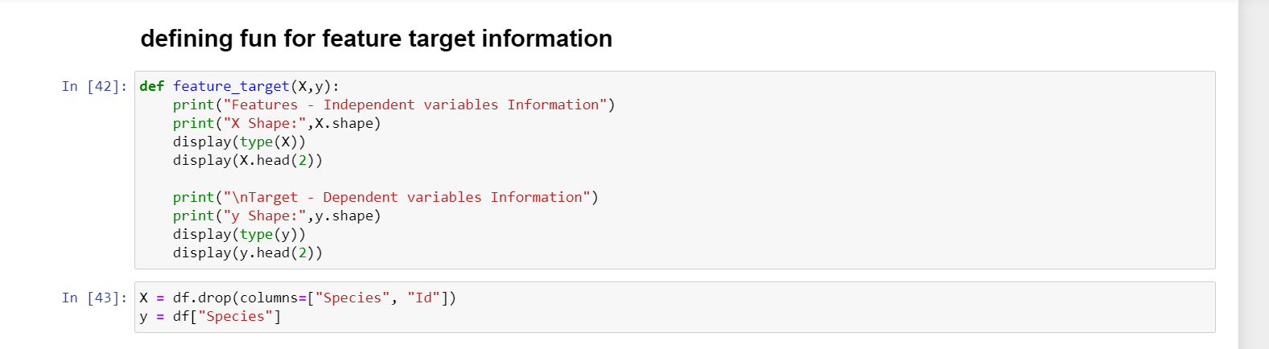

Step:27 Splitting Train , Test, Validation

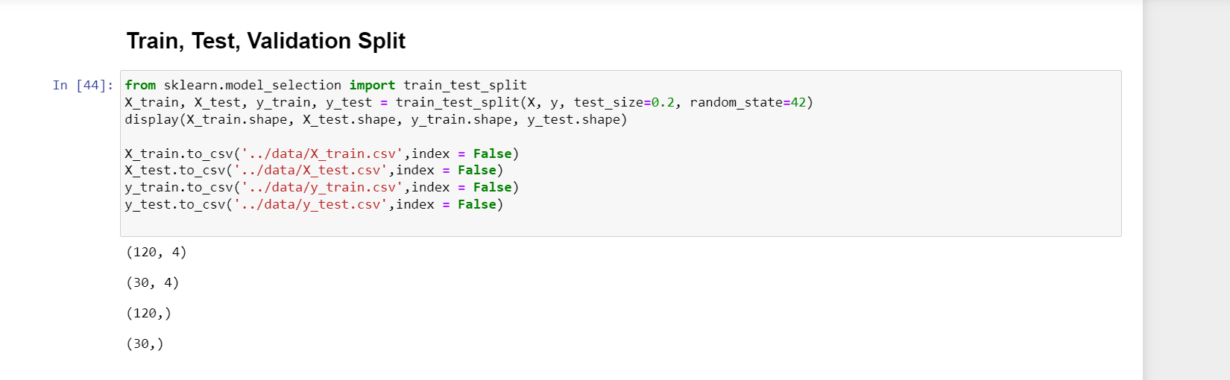

Step: 28 Reading train , test, val files

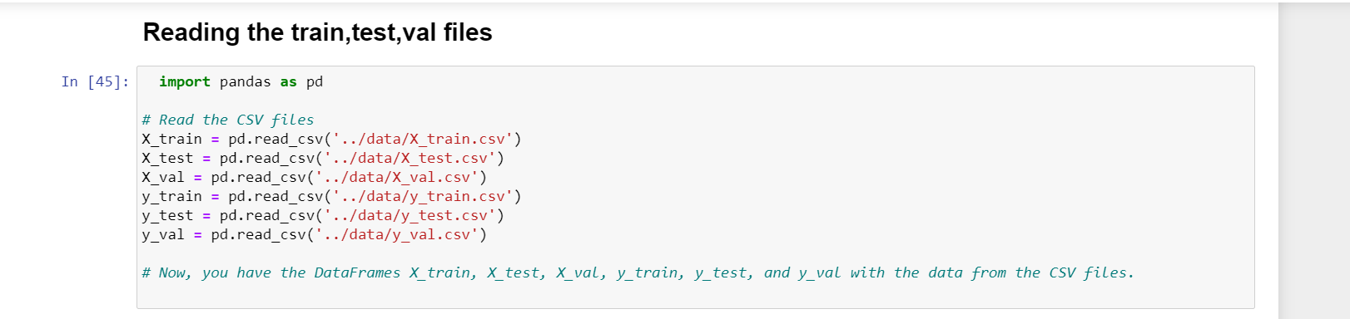

Step: 29 x _ train

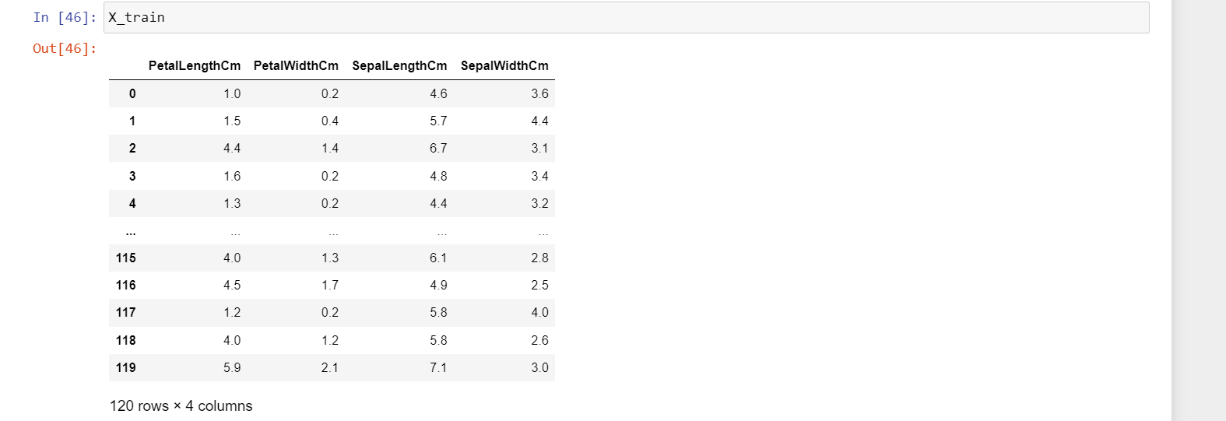

Step :30 Saving train, test, val, files in my sql

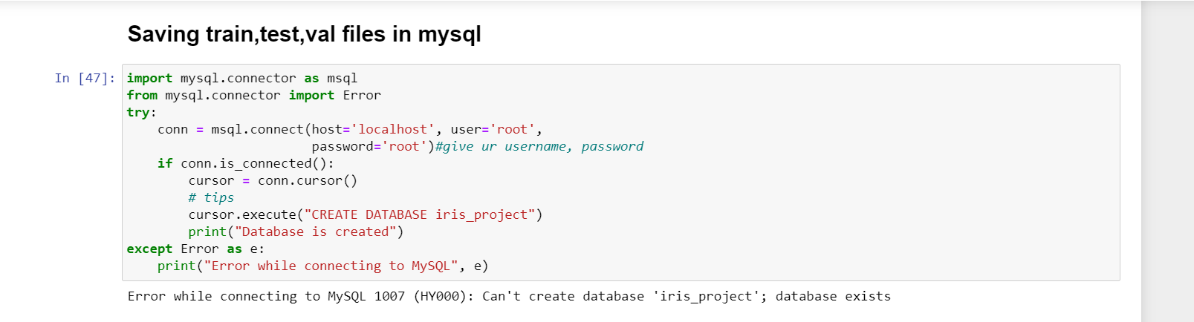

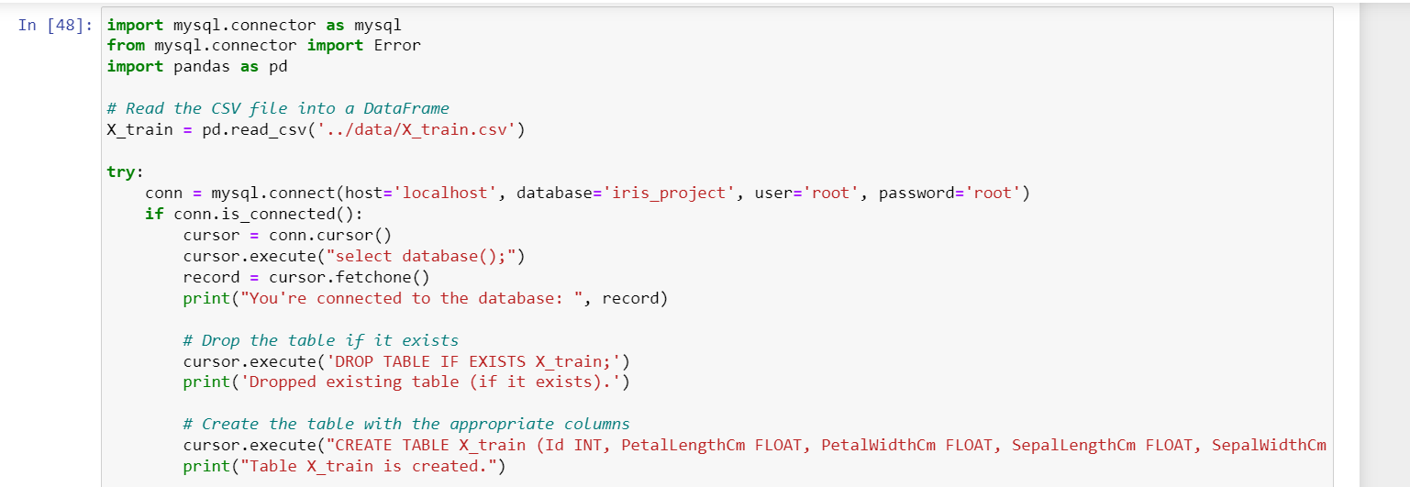

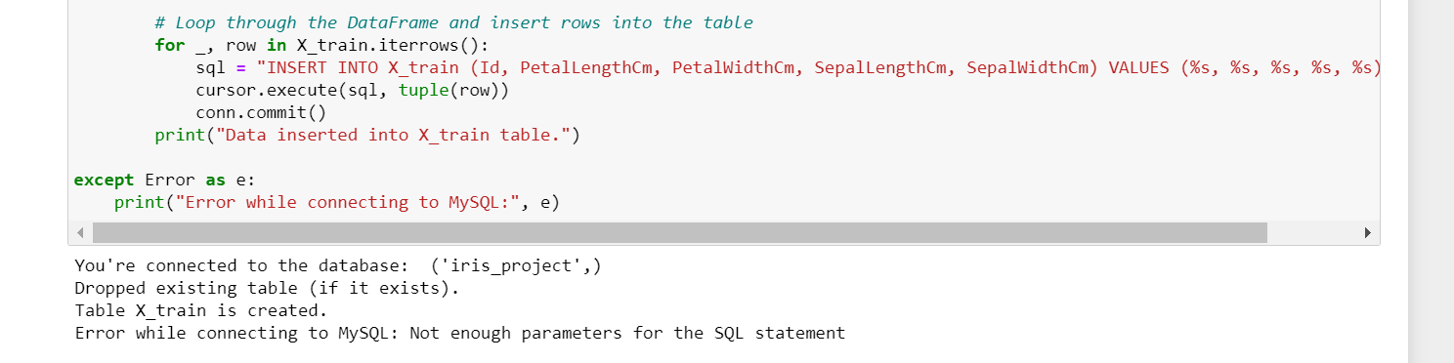

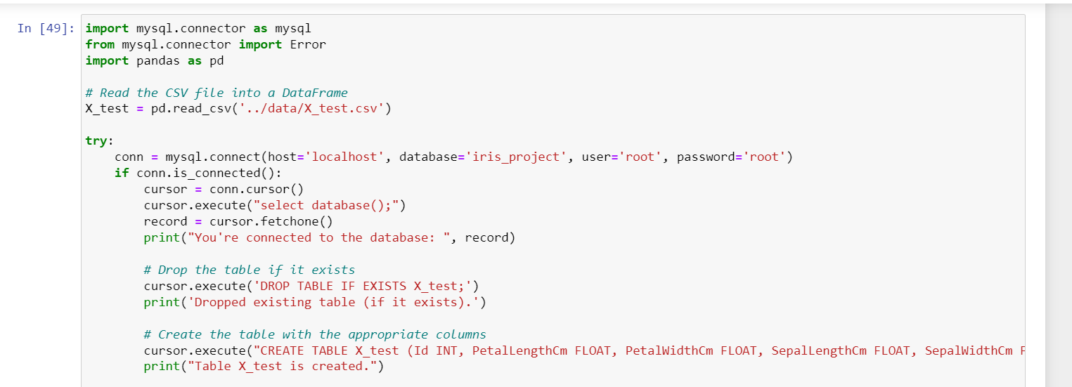

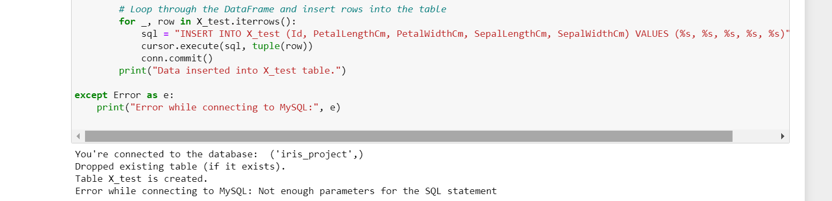

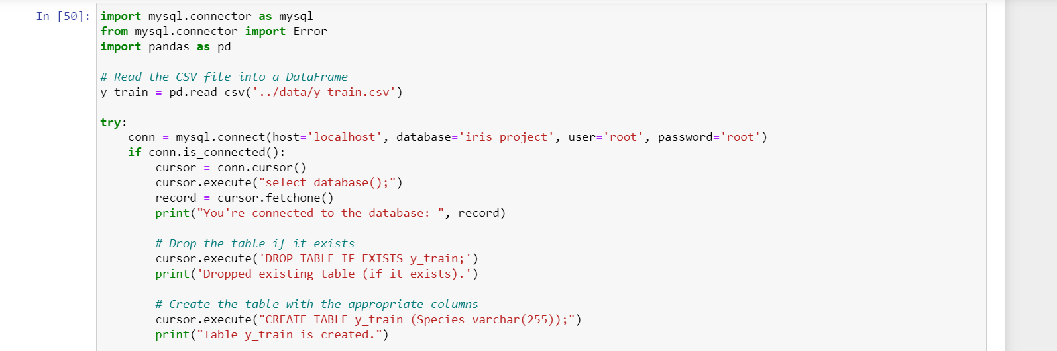

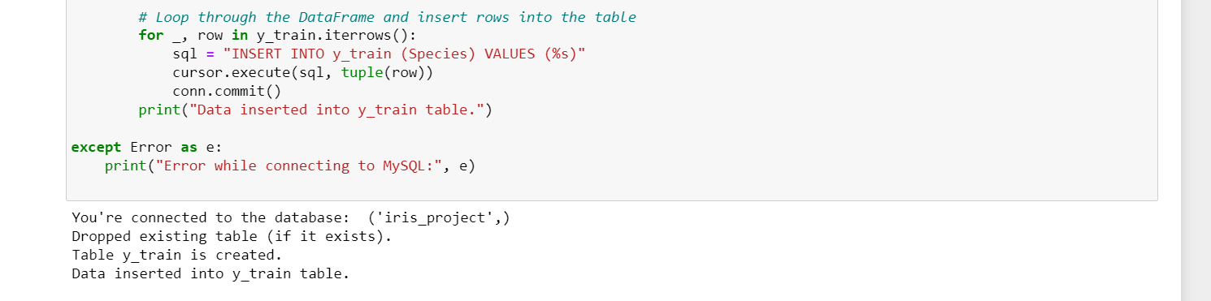

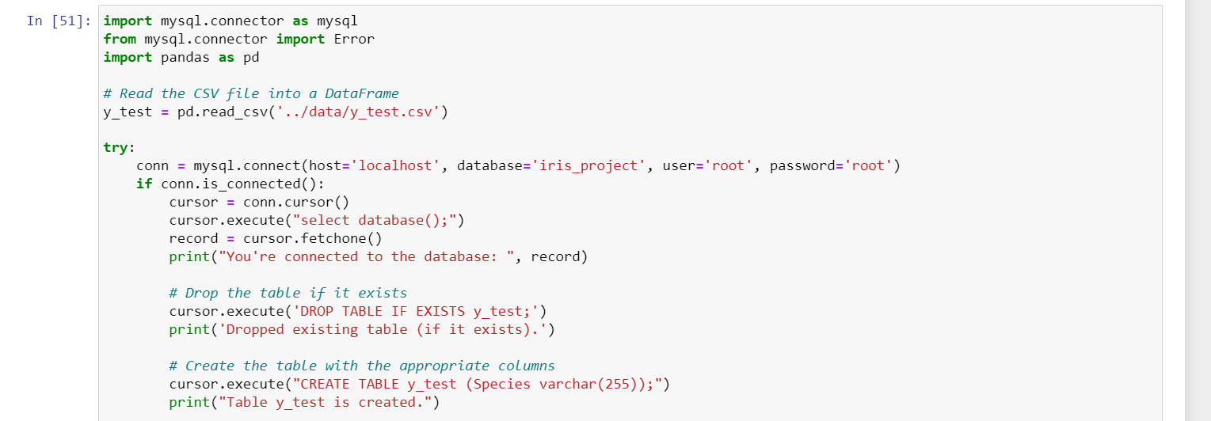

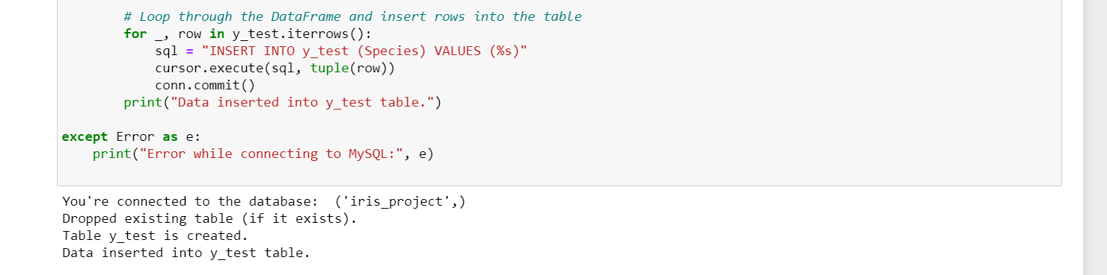

: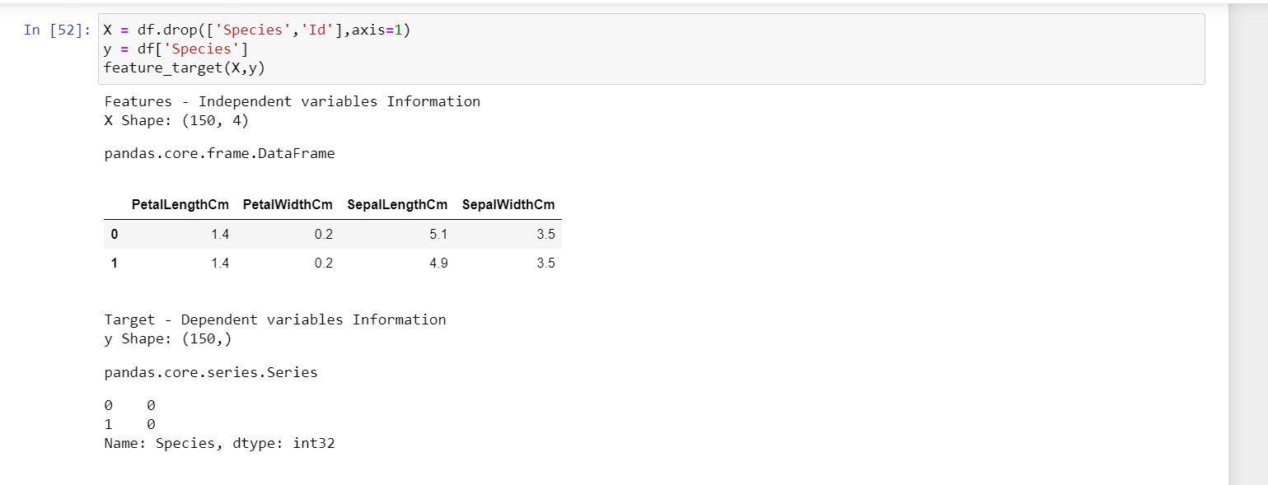

Step : Importing Libraray



Step: Training and predicting the model

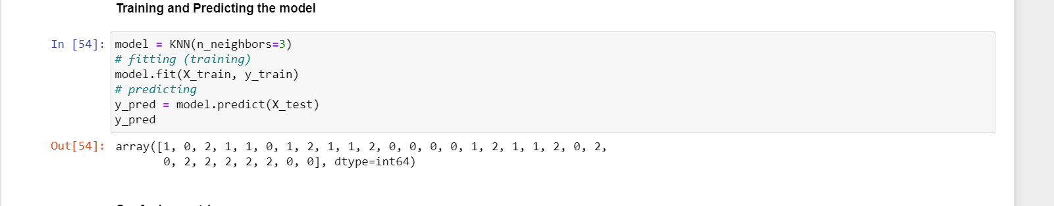

Step : confusion matrix

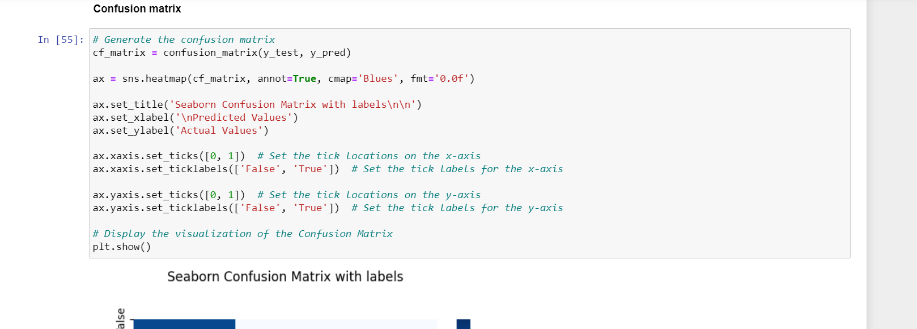

Step: Classification Report

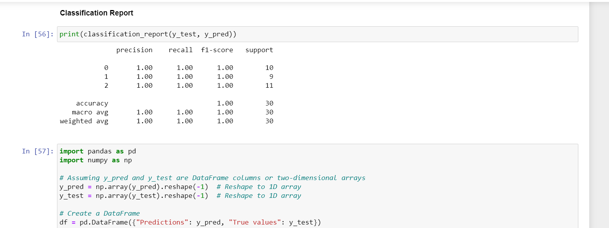

Step : Calling Df

